Lesson 4 - Jesus today and Forever
Pre K - Kinder (Preschool - Kindergarten)

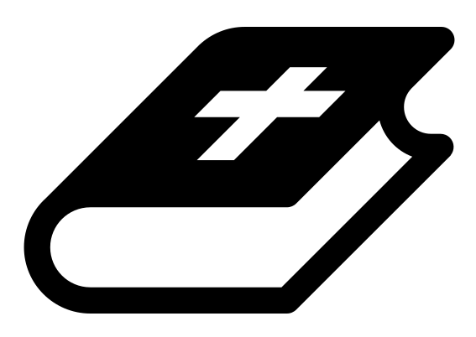 Month 1 - Bible Verse
“I am the Alpha and the Omega,” says the Lord God, “who is, and who was, and who is to come, the Almighty.” Revelation 1:8

 Lesson Outline
- Arrival
- Intro
- Snack
- Bible Verse & Teaching
- Lesson Video
- Lesson Questions
- Declarations
- Centers
- Outro
- Pick up

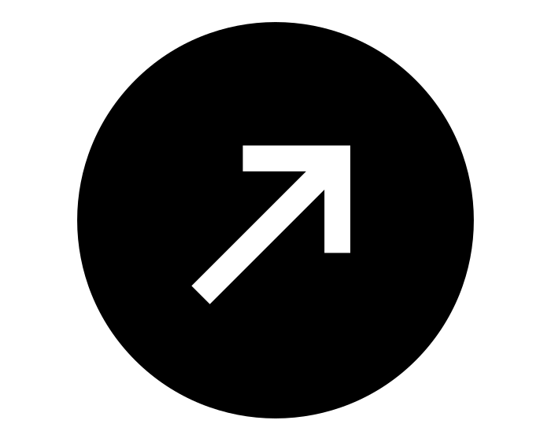Intro & Outro
Here are a few options for the beginning and end of your lesson times. Below are some suggested options:

- Worship: You can have a volunteer lead a worship song with an instrument. Worship flags and toy instruments help keep kids engaged. If you don't have a musician, a worship song or video can work.
- Brain Break: A brain break can be inserted at any point in the lesson to give everyone’s brain a break. This helps children get their wiggles out to help them focus on the lesson. You can use one of the video clips associated with this curriculum. If you don’t have video capabilities play a general game like Simon Says or Freeze Dance, etc.
- Freeplay: Divide the room into a few different stations with board games, blocks, activities, etc.

Bible Verse and Teaching
Recite the monthly Bible verse (repetition is key). You can help the children make up hand motions that go with the verse.

Then say: “Last week we talked about how Jesus was in the beginning with God. Now this week we are going to talk about where Jesus is today, right now, as we sit here in this room!

“So let's process this together: so Jesus comes to the earth as a baby, he does ministry, dies on the cross, rises from the dead and then ascends into heaven. Then what? (Let children answer) In Hebrews it tells us: he ascended and is seated at the right hand of Father God, waiting until the day he can return to the Earth. So what do you think he’s doing up there? Just chilling out, playing his Nintendo as he waits? (Let children answer)

“Let’s watch our video, and see what Jesus is doing while He waits.”

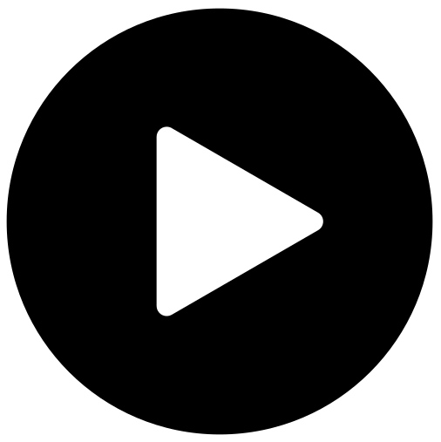 Lesson Video
Video 2-Jesus on the Timeline (rewatch)

 Discussion Questions (answers)
- What is Jesus doing while he waits? (praying, going before God for us)
- What is Jesus waiting for? (To return to the Earth)
- What does Hebrews describe Jesus as? (our High Priest)

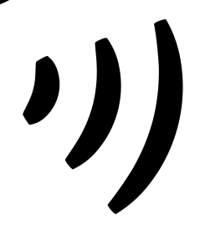 Declarations
Say this together:
I am a child of God
I am fearfully and wonderfully made
Jesus’ blood paid for EVERYTHING
Nothing can separate me from His love
With God ALL THINGS are possible
His presence is transforming my life!

 Centers
Centers are multiple activities laid out in a single classroom. After the lesson, divide the room into even groups, with one group doing the craft and the other doing the lesson activity.

 Activity: Stand Up/Sit Down
Say: “Jesus is seated by the right hand of Father God.”
Instructions:
- Have children stand in a line.
- A volunteer gives the commands “stand up” or “sit down,” and if a child does the incorrect command, they are out. To make it more challenging, give the commands quickly, or give the same command back to back.
- The last child who doesn't get out, wins.

Craft: Jesus’ Praying Hands
Say: “Jesus is in heaven right now seated next to the Father, praying for us!”
Items needed:
- Jesus’ Praying Hands sheet
- Scissors
- Crayons or markers
Preparations:
- Print
Instructions:
- Cut praying hands.
- Fold on the dotted line.
- Color and decorate.

