Lesson 3 - Jesus in the Beginning
Nursery (6 mo - 2 years)

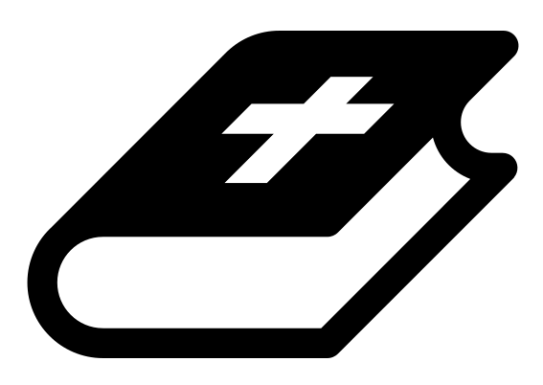 Month 1 - Bible Verse
“I am the Alpha and the Omega,” says the Lord God, “who is, and who was, and who is to come, the Almighty.” Revelation 1:8

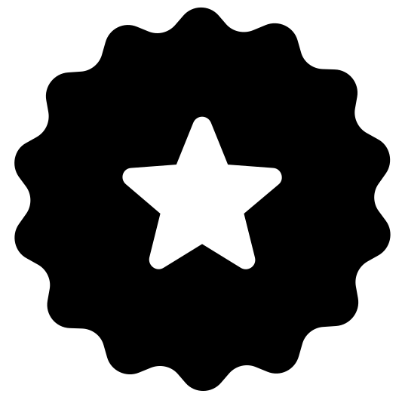 Main Goals
Create a safe environment. Impart God’s love and blessing through your words, body language, and attitude in your interactions with the children.

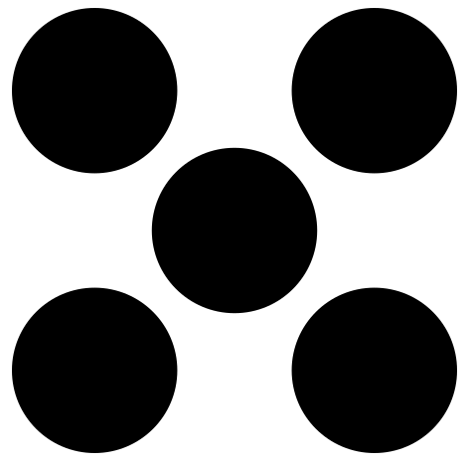 Centers
Centers are multiple activities laid out in a single classroom. For example, lay out the room with three different play activities before children enter. Allow the children to choose which one they would like to engage with.
- Freeplay (i.e. playdough, blocks, toys)
- Activity (i.e. a lesson-based activity or craft)

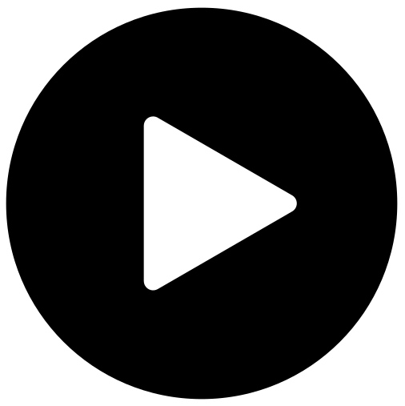 Lesson Video
Video 2- Jesus in the beginning

 Craft: In the Beginning Coloring Sheet
Items needed:
- In the Beginning coloring sheet
Preparations:
- Print
Instructions:
- Allow children to color.

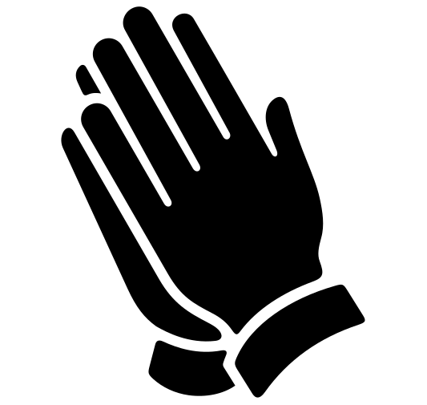Prayer Tips
Start with Thanksgiving:
“Thank you God for this beautiful gift.”
“Thank you God that you have a plan from beginning to end.”

Worship God (turn your heart towards the Lord):
Worship while holding or sitting with babies, telling God who He is.
Tell God:
- “God, you are good!
- “God, you are a protector.”
- “God, you are trustworthy; we trust your plans, Father.”

Intercede for the children:
Pray for each baby and for their families.

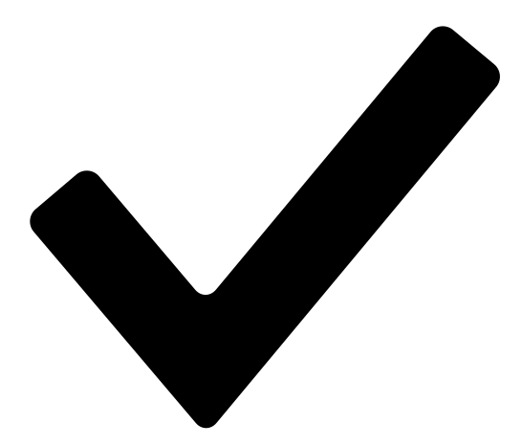 Prayer Points
- Pray that these children would have a passion for sharing Jesus.
- Pray that they would be mighty men and women of the Word.
- Pray courage and boldness over them as they live their lives for Christ.

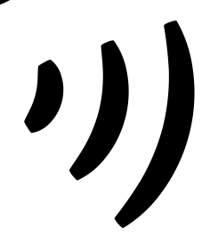 Declarations
Say this together:
I am a child of God
I am fearfully and wonderfully made
Jesus’ blood paid for EVERYTHING
Nothing can separate me from His love
With God ALL THINGS are possible
His presence is transforming my life!

