Lesson 3 - Jesus in the Beginning
Elementary (1st grade - 3rd grade)

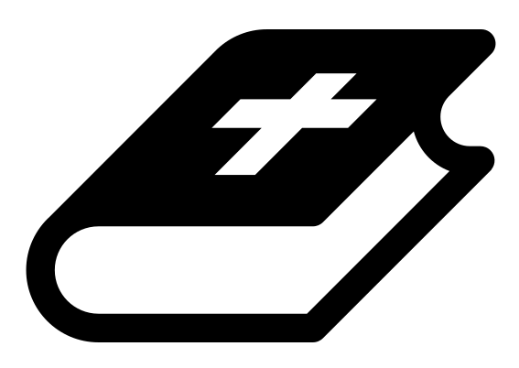 Month 1 - Bible Verse
“I am the Alpha and the Omega,” says the Lord God, “who is, and who was, and who is to come, the Almighty.” Revelation 1:8

 Lesson Outline
- Arrival
- Intro
- Snack
- Bible Verse & Teaching
- Lesson Video
- Discussion Questions
- Declarations
- Activation Station
- Centers
- Outro
- Pick up

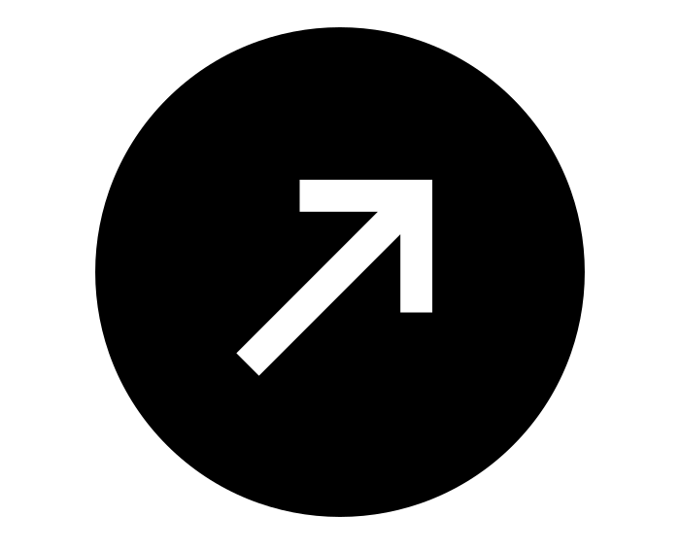Intro & Outro
Here are a few options for the beginning and end of your lesson times. Below are some suggested options:

- Worship: You can have a volunteer lead a worship song with an instrument. Worship flags and toy instruments help keep kids engaged. If you don't have a musician, a worship song or video can work.
- Brain Break: A brain break can be inserted at any point in the lesson to give everyone’s brain a break. This helps children get their wiggles out to help them focus on the lesson. You can use one of the video clips associated with this curriculum. If you don’t have video capabilities play a general game like Simon Says or Freeze Dance, etc.
- Freeplay: Divide the room into a few different stations with board games, blocks, activities, etc.

Bible Verse and Teaching
Recite the monthly Bible verse (repetition is key). You can help the children make up hand motions that go with the verse.

Then say: “The last two weeks we talked about John when he was in prison. Who came to visit him? (Let children answer) Yes! Jesus. But Jesus looked different, right? Can you remember what he looked like? (Let children answer) And Jesus spoke to John. What did he say? (Let children answer) He said, ‘Do not be afraid, I am the Alpha and Omega,’ which means, ‘I am the beginning and the last.’

“Did you know that Jesus was actually with God in the beginning!? John writes, ‘In the beginning was the Word, and the Word was with God, and the Word was God.’ What do you think ‘the Word’ stands for in this? (Let children answer) ‘the Word’ actually means JESUS! John 1:14 says, ‘The Word became flesh and lived among us.’ So let's try reading it this way: ‘In the beginning was Jesus. Jesus was with God, and Jesus was God!’

“Let’s watch our video to learn more.”

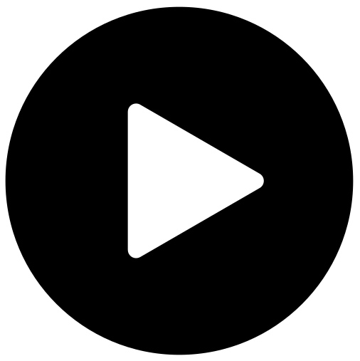 Lesson Video
Video 2-Jesus on the Timeline

 Discussion Questions
- What stuck out to you in that video?
- What does “the Word” stand for in John 1?
- Where was Jesus in the beginning?

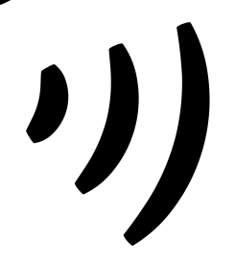 Declarations
Say this together:
I am a child of God
I am fearfully and wonderfully made
Jesus’ blood paid for EVERYTHING
Nothing can separate me from His love
With God ALL THINGS are possible
His presence is transforming my life

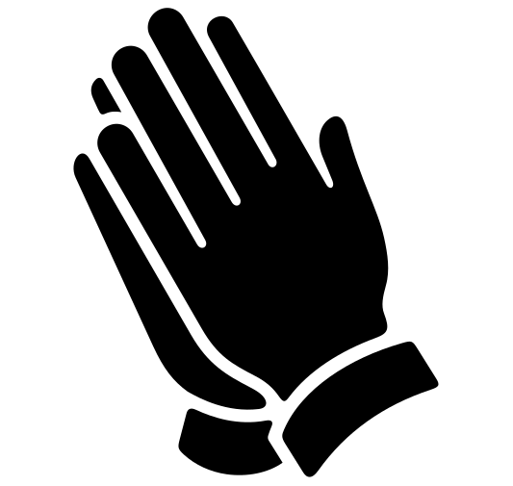Activation Station
Items needed:
- Activation Station sheet
- Crayons or colored pencils
Preparations:
- Print activation worksheet
Instructions:
- Read the top of the worksheet out loud, and invite the Holy Spirit. Have children draw or write what they are seeing from the Lord.
- Take turns sharing what the Holy Spirit showed them.

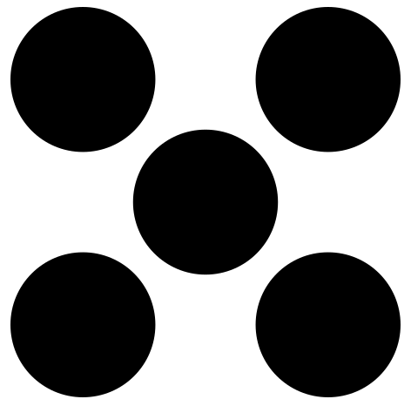 Centers
Centers are multiple activities laid out in a single classroom. After the lesson, divide the room into even groups with one group doing the craft and one group doing the lesson activity.

 Activity: Jesus Through the Timeline
Say: “We can look at the timeline of God and find Jesus everywhere. We are going to make a timeline and pretend this hula hoop is Jesus. We want his kingdom to come quickly!”
Items needed:
- 2 hula hoops
Instructions:
- Make two teams of three or more.
- Have the teams stand in two parallel lines holding hands. Each team represents a timeline.
- The object of the game is to pass the hoop quickly down the timeline until it reaches the last person (the end). To do this, children will step through the hula hoop one at a time without letting go of their teammates' hands.
- The first team to get the hula hoop to the end, wins!
- **To make it harder, you can use blindfolds.**

Craft: In the Beginning Cut & Paste
Items needed:
- In the Beginning cut & paste
- Scissors
- Glue
Preparations:
- Print
Instructions:
- Have children follow the instructions on the activity sheet.

