\
\

Lesson 3 - Jesus in the Beginning
Elementary (4th grade - 6th grade)

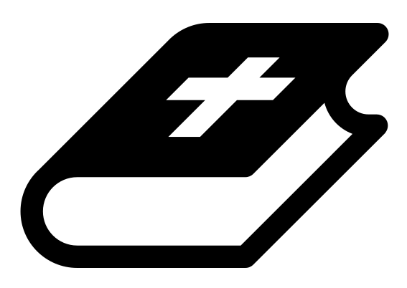 Month 1 - Bible Verse
“I am the Alpha and the Omega,” says the Lord God, “who is, and who was, and who is to come, the Almighty.” Revelation 1:8
 Lesson Outline
- Arrival
- Intro
- Snack
- Memory Verse
- Bible Reading & Discussion
- Lesson Video
- Declarations
- Activation Station
- Craft/Activity
- Outro
- Pick up

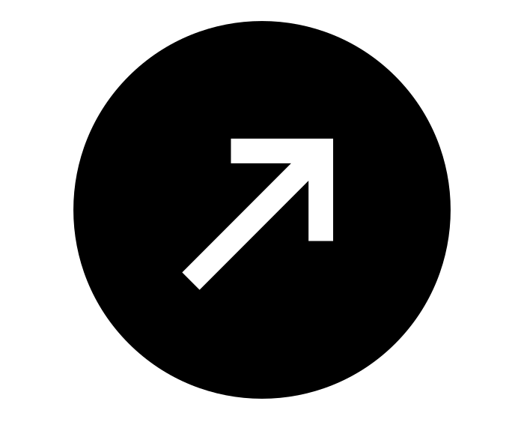Intro & Outro
Here are a few options for the beginning and end of your lesson times. Below are some suggested options:

- Worship: You can have a volunteer lead a worship song with an instrument. Worship flags and toy instruments help keep kids engaged. If you don't have a musician, a worship song or video can work.
- Centers: Divide the room into a few different stations, for example, one with card games, another with free drawing/coloring, etc.
Bible Verse and Teaching
Recite the monthly Bible verse (repetition is key). You can help the children make up hand motions that go with the verse.

Then say: “The last two weeks we talked about John when he was in prison. Who came to visit him? (Let children answer) Yes! Jesus. But Jesus looked different, right? Can you remember what he looked like? (Let children answer) And Jesus spoke to John. What did he say? (Let children answer) He said, ‘Do not be afraid, I am the Alpha and Omega,’ which means, ‘I am the beginning and the last.’

“Did you know that Jesus was actually with God in the beginning!? John writes, ‘In the beginning was the Word, and the Word was with God, and the Word was God.’ What do you think ‘the Word’ stands for in this? (Let children answer) ‘the Word’ actually means JESUS! John 1:14 says, ‘The Word became flesh and lived among us.’ So let's try reading it this way: ‘In the beginning was Jesus. Jesus was with God, and Jesus was God!’

“Let’s watch our video to learn more.”

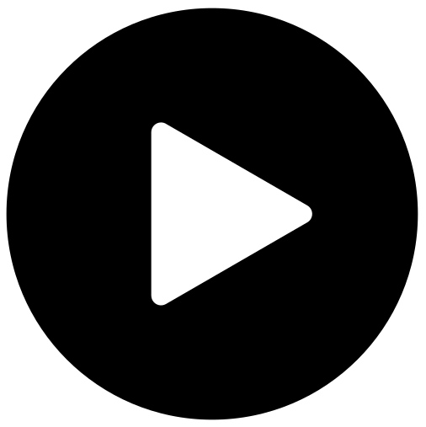 Lesson Video
Video 2-Jesus on the Timeline

 Discussion Questions
- What stuck out to you in that video?
- What does “the Word” stand for in John 1?
- Where was Jesus in the beginning?

Bible Reading & Discussion
Allow around 15-20 min for this section. Give each student a Bible. Break students into groups and assign them a scripture to read together. After they have some time to discuss, have them nominate a group member to read the scripture and share what they think it means.

Verses & Questions
- John 1-5
  - What does John mean when he says, “the Word”? (“The Word” is talking about Jesus. When Kings would deliver messages to people, they would send their word through a messenger, a person that would go and declare that message on the King's behalf. Jesus is God’s messenger; he’s the the very “word” of God.)

  - What does it mean that “the Word was with God in the beginning”? (Jesus, who is the messenger of God, or “word of God,” was there with his father and the Holy Spirit when the world was being created.)
  - What does this mean for us today? (Jesus is the light and no darkness can overcome him.)

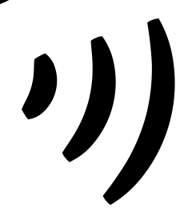 Declarations
Say this together:
I am a child of God
I am fearfully and wonderfully made
Jesus’ blood paid for EVERYTHING
Nothing can separate me from His love
With God ALL THINGS are possible
His presence is transforming my life!

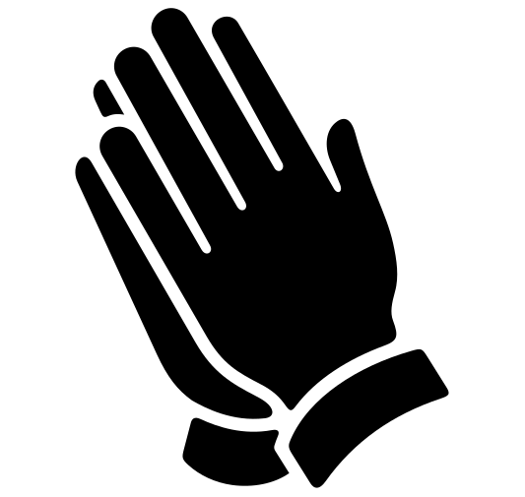Activation Station
Items needed:
- Activation Station sheet
- Crayons or colored pencils
Preparations:
- Print activation worksheet
Instructions:
- Read the top of the worksheet out loud, and invite the Holy Spirit. Have children draw or write what they are seeing from the Lord.
- Take turns sharing what the Holy Spirit showed them.

 Activity: Jesus Through the Timeline
Say: “We can look at the timeline of God and find Jesus everywhere. We are going to make a timeline and pretend this hula hoop is Jesus. We want his kingdom to come quickly!”

Items needed:
- 2 hula hoops
Instructions:
- Make two teams of three or more.
- Have the teams stand in two parallel lines holding hands. Each team represents a timeline.
- The object of the game is to pass the hoop quickly down the timeline until it reaches the last person (the end). To do this, children will step through the hula hoop one at a time without letting go of their teammates' hands.
- The first team to get the hula hoop to the end, wins!
- **To make it harder, you can use blindfolds.**

Craft: Word Search
Items needed:
- Word search
- Pencils
Preparations:
- Print

