Lesson 2 - The Spirit of Prophecy
Toddler (2 years - 4 years)

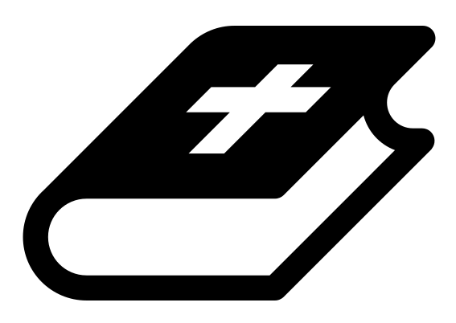 Month 1 - Bible Verse
“I am the Alpha and the Omega,” says the Lord God, “who is, and who was, and who is to come, the Almighty.” Revelation 1:8

 Lesson Outline
- Arrival
- Intro
- Snack
- Bible Verse
- Lesson Video
- Lesson Questions
- Centers
- Outro
- Pick up

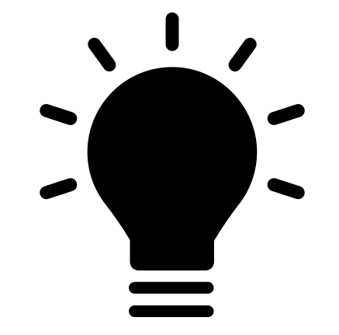 Helpful Tips
While reading the lesson or watching the video, we recommend giving the children snacks, playdough, air-dry clay, etc. This can help keep the children grounded and focused on the lesson.

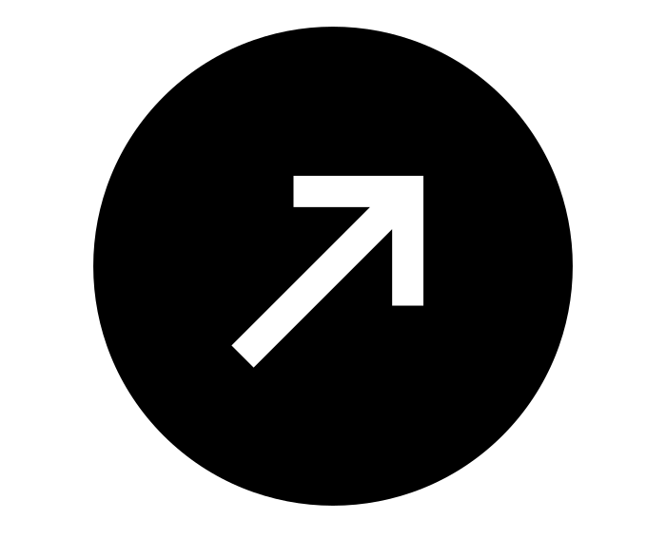Intro & Outro
Here are a few options for the beginning and end of your lesson times. Below are some suggested options:
- Worship: You can have a volunteer lead a worship song with an instrument. Worship flags and toy instruments help keep kids engaged. If you don't have a musician, a worship song or video can work.
- Brain Break: A brain break can be inserted at any point in the lesson to give everyone’s brain a break. This helps children get their wiggles out to help them focus on the lesson. You can use one of the video clips associated with this curriculum. If you don’t have video capabilities play a general game like Simon Says or Freeze Dance, etc.
- Freeplay: Divide the room into a few different stations with board games, blocks, activities, etc.

Bible Verse
Recite the monthly Bible verse (repetition is key). You can help the children make up hand motions that accompany the verse.

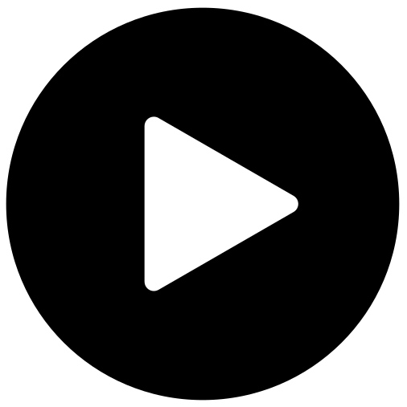 Lesson Video
Video 1- The Testimony Of Jesus (rewatch)

 Discussion Questions
- What stuck out to you in that video?
- What is a testimony? (someone sharing or writing down what they have seen, heard or experienced to prove that it is true)
- Who is the fulfillment of God's promises?

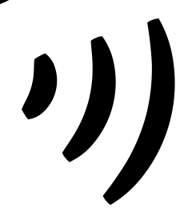 Declarations
Say this together:
I am a child of God
I am fearfully and wonderfully made
Jesus’ blood paid for EVERYTHING
Nothing can separate me from His love
With God ALL THINGS are possible
His presence is transforming my life!

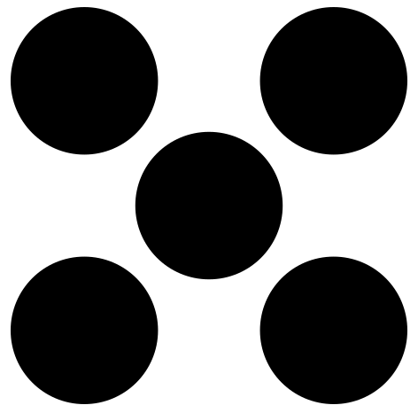 Centers
Centers are multiple activities laid out in a single classroom. After the lesson, divide the room into even groups, with one group doing the craft and the other doing the lesson activity.

 Activity: Holy Spirit Is Showing Me
Take time to allow the children to hear from the Holy Spirit.

Items needed:
- Holy Spirit Is Showing Me sheet
Instructions:
- Put on soaking or worship music.
- Tell children to close their eyes.
- Invite the Holy Spirit to come, and reveal Jesus to us!
- Let them draw what they are seeing.
- Let them share.

Craft: Alpha and Omega Color by Number
Say: “John had a vision of Jesus! But he looked different than you may think. Let's use our color key to make our Jesus look like the one in John’s vision.”

Items needed:
- Jesus coloring sheet
- Crayons (colors that match the color key)
Preparations:
- Print
Instructions:
- Have children follow the color key to color their sheet.

