Lesson 2 - The Spirit of Prophecy
Elementary (4th grade - 6th grade)

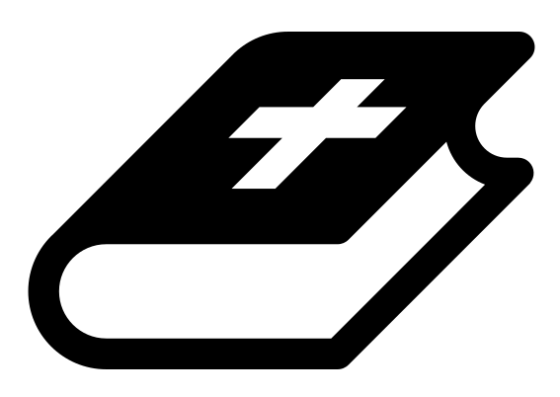 Month 1 - Bible Verse
“I am the Alpha and the Omega,” says the Lord God, “who is, and who was, and who is to come, the Almighty.” Revelation 1:8
 Lesson Outline
- Arrival
- Intro
- Snack
- Memory Verse
- Bible Reading & Discussion
- Lesson Video
- Declarations
- Activation Station
- Craft/Activity
- Outro
- Pick up

Intro & Outro
Here are a few options for the beginning and end of your lesson times. Below are some suggested options:

- Worship: You can have a volunteer lead a worship song with an instrument. Worship flags and toy instruments help keep kids engaged. If you don't have a musician, a worship song or video can work.
- Centers: Divide the room into a few different stations, for example, one with card games, another with free drawing/coloring, etc.

Bible Verse and Teaching
Recite the monthly Bible verse (repetition is key). You can help the children make up hand motions that go with the verse.

Then say: “Last week we talked about what a testimony is. Does anyone remember? (Let children answer) Yes, a testimony is someone sharing or writing down what they have seen, heard or experienced to prove that it is true! The Bible isn't just a story book; it’s people many years ago writing down what they experienced.

“The Bible also tells us that the testimony of Jesus is the spirit of prophecy. What do you think that means? (Let children answer) Last year we learned that God promised to redeem all things, right? Well, Jesus is the one who will make those promises come true. The truth about what Jesus has done, who He is and what He will do in the future is the fulfillment of all God's promises. This means that when God made promises to Adam, Abraham and the prophets, all those promises will come true because of Jesus. Isn't that amazing?

“Let’s watch our video to learn more.”

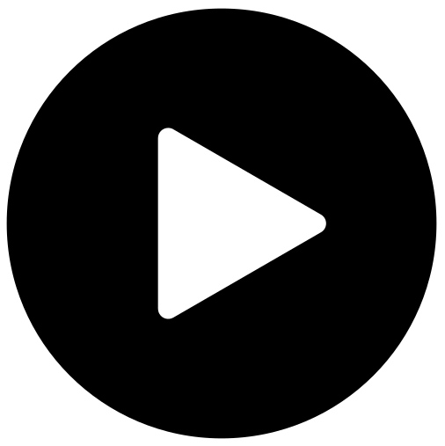 Lesson Video
Video 1-The Testimony Of Jesus (rewatch)

 Discussion Questions
- What stuck out to you in that video?
- What is a testimony? (someone sharing or writing down what they have seen, heard or experienced to prove that it is true)
- Who is the fulfillment of God's promises?

Bible Reading & Discussion
Allow around 15-20 min for this section. Give each student a Bible. Break students into groups and assign them a scripture to read together. After they have some time to discuss, have them nominate a group member to read the scripture and share what they think it means.

Verses & Questions
- 2 Peter 1:19-21
  - Did the prophets make things up when they wrote down God’s promises? (No, it was God’s Spirit who told them what to write down.)
  - Was there a similar theme to all the things that the prophets wrote down? (God’s Spirit “carried along” all their writings in the same general direction. They all pointed to God’s plan of redeeming all things through Jesus.)
- Revelation 19:10
  - What is John told by the Angel not to do? (John is told not to worship the Angel or the prophetic message itself, but to worship Jesus.)
  - What does “Prophecy” mean here? (A prophecy is a promise that God has made that will one day come true.)
  - What does “Spirit of Prophecy” mean here? (All the promises God made to his people weren’t random; they were all connected by the Spirit and they all point to God’s plan to redeem all things and make all things new.)
  - What does it mean that “Spirit of Prophecy is the Testimony of Jesus”? (The true testimony about what Jesus has done, who Jesus is, and what Jesus will do in the future, is how God makes all his promises come true.)

 Declarations
Say this together:
I am a child of God
I am fearfully and wonderfully made
Jesus’ blood paid for EVERYTHING
Nothing can separate me from His love
With God ALL THINGS are possible
His presence is transforming my life!

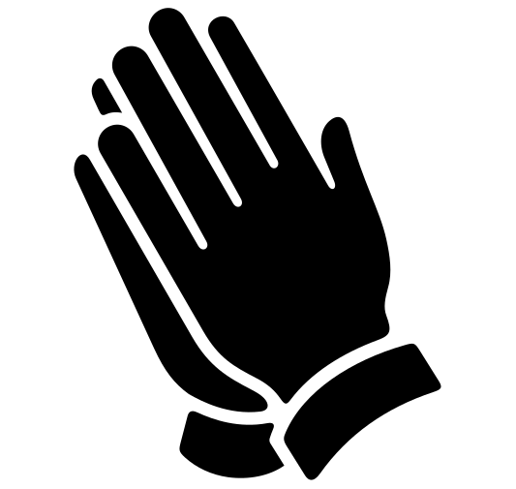Activation Station
Items needed:
- Activation Station sheet
- Crayons or colored pencils

Preparations:
- Print activation worksheet
Instructions:
- Read the top of the worksheet out loud, and invite the Holy Spirit. Have children draw or write what they are seeing from the Lord.
- Take turns sharing what the Holy Spirit showed them.

 Activity: Act It Out
Items needed:
- Action cards
- Blank paper
- Pencils
Preparations:
- Print and cut out action cards
- Fold action cards and place in a bowl or hat
Instructions:
- Give each child a blank piece of paper and a pencil.
- Have each child take turns to randomly pick an action card and secretly read it, then quietly act it out.
- All the other students watch and try to figure out what they are acting out. They may not blurt it out but instead secretly write it down on their paper.
- All at once, have the children reveal what they thought the person was acting out.
- Compare and see how different people take away different ideas of what was happening.
- Repeat until everyone has taken a turn being the actor.

Craft: Alpha and Omega Color by Number
Say: “John had a vision of Jesus! But he looked different than you may think. Let's use our color key to make our Jesus look like the one in John’s vision.”
Items needed:
- Jesus coloring sheet
- Crayons (colors that match the color key)
Preparations:
- Print
Instructions:
- Have children follow the color key to color their sheet.

