Lesson 1 - The Testimony of Jesus
Elementary (1st grade - 3rd grade)
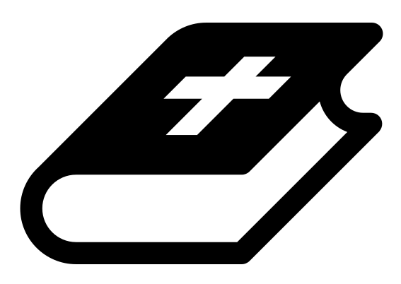 Month 1 - Bible Verse
“I am the Alpha and the Omega,” says the Lord God, “who is, and who was, and who is to come, the Almighty.” Revelation 1:8

 Lesson Outline
- Arrival
- Intro
- Snack
- Bible Verse & Teaching
- Lesson Video
- Discussion Questions
- Declarations
- Activation Station
- Centers
- Outro
- Pick up

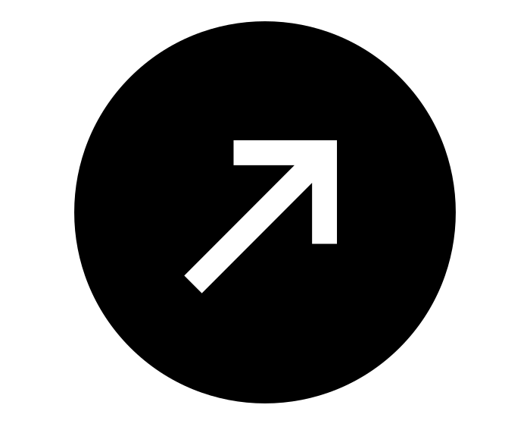Intro & Outro
Here are a few options for the beginning and end of your lesson times. Below are some suggested options:

- Worship: You can have a volunteer lead a worship song with an instrument. Worship flags and toy instruments help keep kids engaged. If you don't have a musician, a worship song or video can work.
- Brain Break: A brain break can be inserted at any point in the lesson to give everyone’s brain a break. This helps children get their wiggles out to help them focus on the lesson. You can use one of the video clips associated with this curriculum. If you don’t have video capabilities play a general game like Simon Says or Freeze Dance, etc.
- Freeplay: Divide the room into a few different stations with board games, blocks, activities, etc.

Bible Verse and Teaching
Recite the monthly Bible verse (repetition is key). You can help the children make up hand motions that go with the verse.

Then say: “We learned about how the Bible is a… what? (Let children answer) YES! The Bible is a timeline. It tells us how things began, how things went wrong and what God’s plan is in the future. You are on the timeline of God!

“So now we are going to talk about the testimony of Jesus. Who can tell me what a testimony is? (Let children answer) A testimony is someone sharing or writing down what they have seen, heard or experienced to prove that it is true. Think about it this way: let's say you and your friend are walking down the street. All of a sudden a cop runs up to your friend and says, “You are under arrest for stealing a car this morning!” Because you were with your friend all morning and you know he did not steal a car, you can give a testimony to prove your friend did not steal it.

“John experienced something wild while he was in prison. He wrote it down and we can now read his testimony about it in the book of Revelation! The whole Bible isn't just stories. It is people writing down what they experienced, saw and heard. Let's watch our video to see what John experienced.”

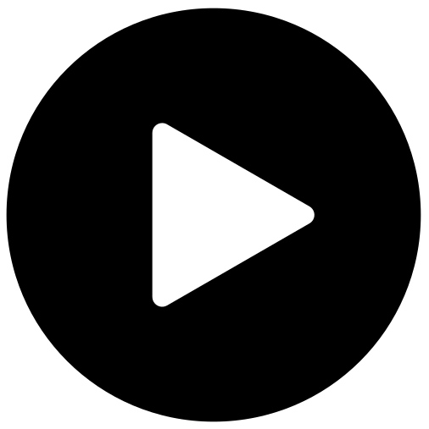 Lesson Video
Video 1-The Testimony Of Jesus

 Discussion Questions
- What happened?
- What did John see?
- What is a testimony? (A testimony is someone sharing or writing down what they have seen, heard or experienced to prove that it is true)

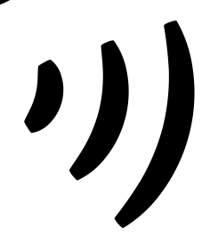 Declarations
Say this together:
I am a child of God
I am fearfully and wonderfully made
Jesus’ blood paid for EVERYTHING
Nothing can separate me from His love
With God ALL THINGS are possible
His presence is transforming my life!

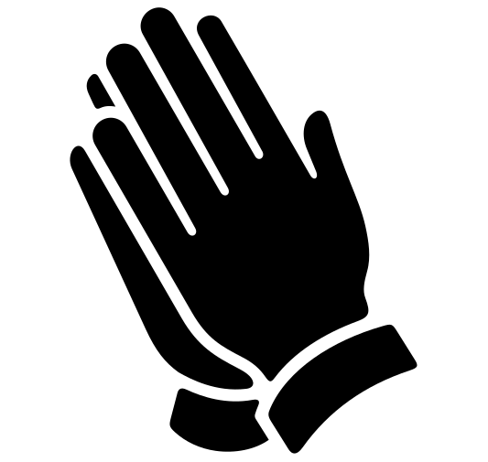Activation Station
Items needed:
- Activation Station sheet
- Crayons or colored pencils
Preparations:
- Print activation worksheet
Instructions:
- Read the top of the worksheet out loud, and invite the Holy Spirit. Have children draw or write what they are seeing from the Lord.
- Take turns sharing what the Holy Spirit showed them.

 Centers
Centers are multiple activities laid out in a single classroom. After the lesson, divide the room into even groups with one group doing the craft and one group doing the lesson activity.

 Activity: Share a Testimony
The bible is a collection of testimonies. It is people who wrote down what they experienced, saw or heard. John was thrown in prison for telling testimonies about Jesus!
Items needed:
- Bible story cards
Preparations:
- Print story cards
- Cut
Instructions:
- Have children sit in a circle.
- Allow children to take turns, picking a story card at random.
- The student secretly reads the card, without telling other students in the circle what it says.
- The student with the card describes the Bible story, while other students in the circle guess which Bible story it is.
- BUT the student whose turn it is must not mention God or Jesus, or they get thrown in jail (kicked out of the circle).
- The last student in the circle (not thrown in jail) wins!

Craft: Memory Verse Coloring Sheet
Items needed:
- Coloring sheet
Preparations:
- Print
Instructions:
- Allow children to color.

