Lesson 1 - The Testimony of Jesus
Pre K - Kinder (Preschool - Kindergarten)

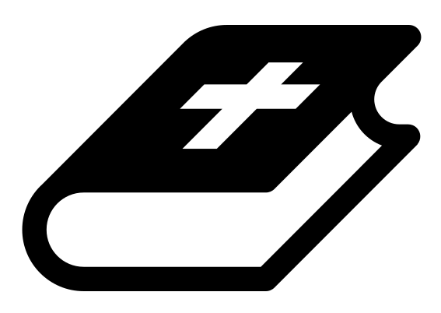 Month 1 - Bible Verse
“I am the Alpha and the Omega,” says the Lord God, “who is, and who was, and who is to come, the Almighty.” Revelation 1:8

 Lesson Outline
- Arrival
- Intro
- Snack
- Bible Verse & Teaching
- Lesson Video
- Lesson Questions
- Declarations
- Centers
- Outro
- Pick up

Intro & Outro
Here are a few options for the beginning and end of your lesson times. Below are some suggested options:

- Worship: You can have a volunteer lead a worship song with an instrument. Worship flags and toy instruments help keep kids engaged. If you don't have a musician, a worship song or video can work.
- Brain Break: A brain break can be inserted at any point in the lesson to give everyone’s brain a break. This helps children get their wiggles out to help them focus on the lesson. You can use one of the video clips associated with this curriculum. If you don’t have video capabilities play a general game like Simon Says or Freeze Dance, etc.
- Freeplay: Divide the room into a few different stations with board games, blocks, activities, etc.

Bible Verse and Teaching
Recite the monthly Bible verse (repetition is key). You can help the children make up hand motions that go with the verse.

Then say: “We learned about how the Bible is a… what? (Let children answer) YES! The Bible is a timeline. It tells us how things began, how things went wrong and what God’s plan is in the future. You are on the timeline of God!

“So now we are going to talk about the testimony of Jesus. Who can tell me what a testimony is? (Let children answer) A testimony is someone sharing or writing down what they have seen, heard or experienced to prove that it is true.

“John experienced something wild while he was in prison. He wrote it down and we can now read his testimony about it in the book of Revelation! The whole Bible isn't just stories. It is people writing down what they experienced, saw and heard. Let's watch our video to see what John experienced.”

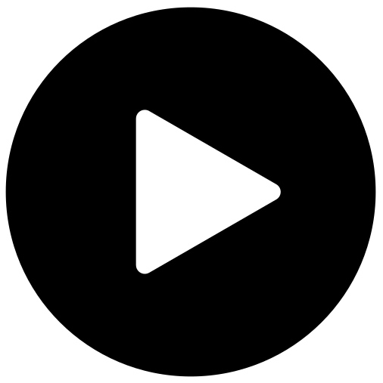 Lesson Video
Video 1- The Testimony Of Jesus

 Discussion Questions
- What happened?
- What did John see?
- What is a testimony? (A testimony is someone sharing or writing down what they have seen, heard or experienced to prove that it is true)

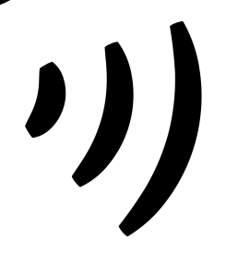 Declarations
Say this together:
I am a child of God
I am fearfully and wonderfully made
Jesus’ blood paid for EVERYTHING
Nothing can separate me from His love
With God ALL THINGS are possible
His presence is transforming my life!

 Centers
Centers are multiple activities laid out in a single classroom. After the lesson, divide the room into even groups, with one group doing the craft and the other doing the lesson activity.

 Activity: Reveal Jesus to Us
Say: “When you close your eyes and picture Jesus, what does he look like to you?”
Items needed:
- Playdough
Instructions:
- Put on soaking or worship music.
- Tell children to close their eyes.
- Invite the Holy Spirit to come, and reveal Jesus to us!
- Allow children an appropriate amount of time to craft their Jesus.
- Let them share why they crafted Him in that way.

Craft: Memory Verse Coloring Sheet
Items needed:
- Coloring sheet
Preparations:
- Print
Instructions:
- Allow children to color.

