Lesson 4 - Jesus Calls Matthew
Toddler (2 years - 4 years)

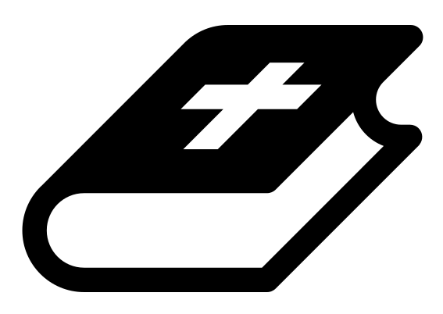 Month 3 - Bible Verse
“For we do not have a high priest who is unable to empathize with our weaknesses, but we have one who has been tempted in every way, just as we are—yet he did not sin.” Hebrews 4:15

 Lesson Outline
- Arrival
- Intro
- Snack
- Bible Verse
- Lesson Video
- Lesson Questions
- Centers
- Outro
- Pick up

 Helpful Tips
While reading the lesson or watching the video, we recommend giving the children snacks, playdough, air-dry clay, etc. This can help keep the children grounded and focused on the lesson.

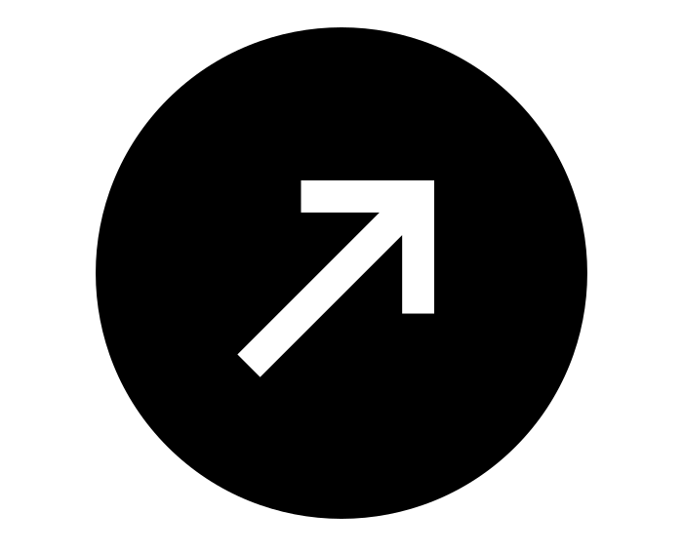Intro & Outro
Here are a few options for the beginning and end of your lesson times. Below are some suggested options:

- Worship: You can have a volunteer lead a worship song with an instrument. Worship flags and toy instruments help keep kids engaged. If you don't have a musician, a worship song or video can work.
- Brain Break: A brain break can be inserted at any point in the lesson to give everyone’s brain a break. This helps children get their wiggles out to help them focus on the lesson. You can use one of the video clips associated with this curriculum. If you don’t have video capabilities play a general game like Simon Says or Freeze Dance, etc.
- Freeplay: Divide the room into a few different stations with board games, blocks, activities, etc.

Bible Verse
Recite the monthly Bible verse (repetition is key). You can help the children make up hand motions that accompany the verse.

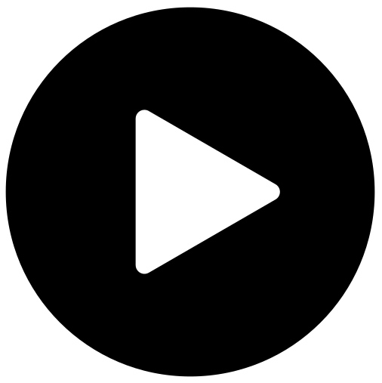 Lesson Video
Video 6- Jesus Calls His Disciples (rewatch)

 Discussion Questions
- What happened? (let children answer)
- What did Jesus say? (follow me)
- Did Matthew follow Jesus? (yes)

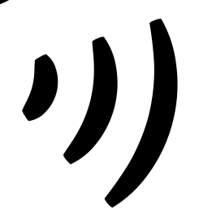 Declarations
Say this together:
I am a child of God
I am fearfully and wonderfully made
Jesus’ blood paid for EVERYTHING
Nothing can separate me from His love
With God ALL THINGS are possible
His presence is transforming my life!

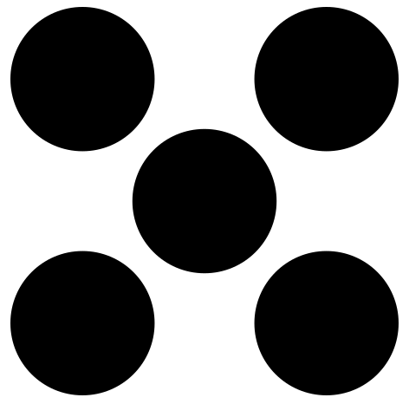 Centers
Centers are multiple activities laid out in a single classroom. After the lesson, divide the room into even groups, with one group doing the craft and the other doing the lesson activity.

 Activity: Jesus Says (Simon Says)
Instructions:
- Play Simon Says, but instead of saying “Simon,” say “Jesus says.”
- The last person standing wins.

Craft: Feet Tracing
Items needed:
- Feet Tracing sheet
- Crayons
Preparations:
- Print
Instructions:
- Place paper on the floor.
- Have the children place their feet on either side of the words “follow me.”
- Volunteers trace their feet.
- Allow children to decorate.

