Lesson 3 - Jesus Calls Peter, James & John
Pre K - Kinder (Preschool - Kindergarten)

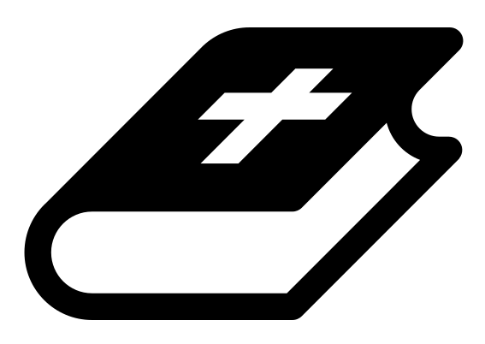 Month 3 - Bible Verse
“For we do not have a high priest who is unable to empathize with our weaknesses, but we have one who has been tempted in every way, just as we are—yet he did not sin.” Hebrews 4:15

 Lesson Outline
- Arrival
- Intro
- Snack
- Bible Verse & Teaching
- Lesson Video
- Lesson Questions
- Declarations
- Centers
- Outro
- Pick up

Intro & Outro
Here are a few options for the beginning and end of your lesson times. Below are some suggested options:

- Worship: You can have a volunteer lead a worship song with an instrument. Worship flags and toy instruments help keep kids engaged. If you don't have a musician, a worship song or video can work.
- Brain Break: A brain break can be inserted at any point in the lesson to give everyone’s brain a break. This helps children get their wiggles out to help them focus on the lesson. You can use one of the video clips associated with this curriculum. If you don’t have video capabilities play a general game like Simon Says or Freeze Dance, etc.
- Freeplay: Divide the room into a few different stations with board games, blocks, activities, etc.

Bible Verse and Teaching
Recite the monthly Bible verse (repetition is key). You can help the children make up hand motions that go with the verse.

Then say: “For the next two weeks, we are going to talk about when Jesus called his disciples. What do you think it means to be a disciple? (Let children answer) A disciple is someone who learns and follows a teacher or Rabbi (which is an Israeli teacher). Do you have a teacher at school? (Let children answer) Do you learn from them? (Let children answer) Do you follow them home or travel with them? (Let children answer)

“When Jesus was a teacher (Rabbi), he would call people, meaning he would ask them to follow him. Many people did! Men and women followed Jesus. They traveled with him, had meals with him and watched him live out His day to day life. His life was a model for them, on how they should live.

“Today we are going to focus on when Jesus called Peter, James and John.
Let’s watch our video to learn more.”

 Lesson Video
Video 6- Jesus Calls His Disciples

 Discussion Questions (answers)
- What happened with Peter? (let children answer)
- What did Jesus ask them? (to leave everything and follow him)
- What does it mean to be fishers of men? (Instead of catching fish out of water, they would snatch people out of darkness.)

 Declarations
Say this together:
I am a child of God
I am fearfully and wonderfully made
Jesus’ blood paid for EVERYTHING
Nothing can separate me from His love
With God ALL THINGS are possible
His presence is transforming my life!

 Centers
Centers are multiple activities laid out in a single classroom. After the lesson, divide the room into even groups, with one group doing the craft and the other doing the lesson activity.

 Activity: Drop Your Nets Relay Race
Say: “Jesus asks us to drop everything and follow Him. He asked Peter and Andrew to drop their nets and follow Him.”
Items needed:
- Net pictures (provided)
- Items for an obstacle course (such as painters tape on the floor, cones, chairs, etc.)
Preparations:
- Print net pictures (one per child)
- Set up obstacle course
Instructions:
- Split into two groups. This is a relay race.
- Have children line up in lines parallel to each other and hand each child a net picture.
- Have the children run to a designated spot, drop their net and go through the obstacle course (this represents following Jesus) before returning to let the next person in line go.
- Repeat until all children have gone through the course.
- The first team to have all children go through, wins!

Craft: Fish Craft (Option 1)
Items needed:
- Fish coloring sheet
- Crayons
Preparations:
- Print
Instructions:
- Give each child a coloring sheet and have them draw tons of fish in the nets.

Craft: Fish Craft (Option 2)
Items needed:
- Fish coloring sheet
- Fish cut & glue pieces
- Glue
- Scissors
Preparations:
- Print
- Cut out the individual fish
Instructions:
- Allow children to color.
- Glue the fish onto the net of the coloring sheet.

