Lesson 3 - Jesus in His Father’s House
Elementary (4th grade - 6th grade)

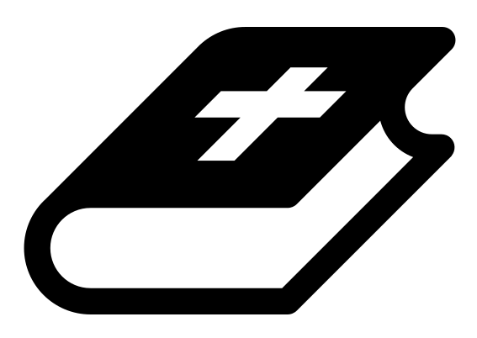 Month 2 - Bible Verse
“The angel of the Lord encamps around those who fear him, and delivers them.” Psalm 34:7

 Lesson Outline
- Arrival
- Intro
- Snack
- Memory Verse
- Bible Reading & Discussion
- Lesson Video
- Declarations
- Activation Station
- Craft/Activity
- Outro
- Pick up

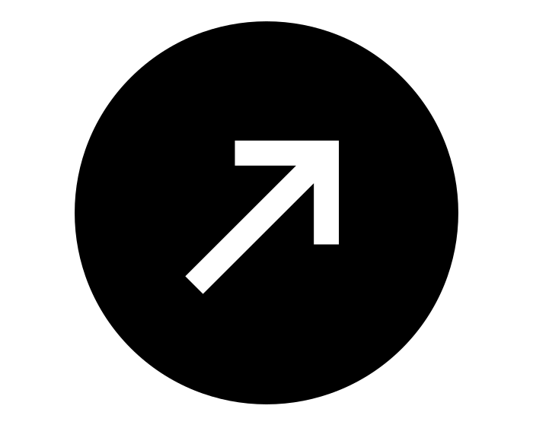Intro & Outro
Here are a few options for the beginning and end of your lesson times. Below are some suggested options:

- Worship: You can have a volunteer lead a worship song with an instrument. Worship flags and toy instruments help keep kids engaged. If you don't have a musician, a worship song or video can work.
- Centers: Divide the room into a few different stations, for example, one with card games, another with free drawing/coloring, etc.

Bible Verse and Teaching
Recite the monthly Bible verse (repetition is key). You can help the children make up hand motions that go with the verse.

Then say: “Today we are going to hear a story about Jesus when he was a young boy. He and his family went on a trip to Jerusalem to celebrate Passover. He was there with lots of his family members. Do any of you gather to celebrate holidays with family members? (Let children answer) Sometimes holidays can get chaotic with all the people around. Jesus' family started to travel back home but soon realized they had left Jesus behind! They searched for Jesus for three days! Can you imagine being lost for three days? (Let children answer)

“Let’s watch our video to find out what happened next.”

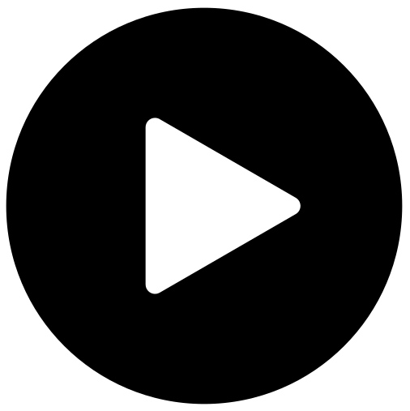 Lesson Video
Video 4- Jesus in His Father’s House

 Discussion Questions
- Where did they find Jesus? (in his Father’s house)
- What is “Fathers’s house” referring to? (the temple)
- What was Jesus doing? (listening to the teachers)

Bible Reading & Discussion
Allow around 15-20 min for this section. Give each student a Bible. Break students into groups and assign them a scripture to read together. After they have some time to discuss, have them nominate a group member to read the scripture and share what they think it means.

Verses & Questions
- Luke 2:41-52
  - Where did they find Jesus? (In the courts of the Temple talking to the teachers of Israel)
  - What was Jesus doing and why were they amazed? (He was listening, asking them questions, and giving answers that were way beyond his years.)
  - What does Jesus call the Temple in Jerusalem? (His Father’s house.)
  - What does this passage mean for us today? (You can know the Bible like Jesus did, even as a kid.)

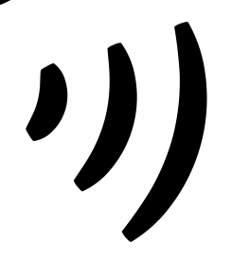 Declarations
Say this together:
I am a child of God
I am fearfully and wonderfully made
Jesus’ blood paid for EVERYTHING
Nothing can separate me from His love
With God ALL THINGS are possible
His presence is transforming my life!

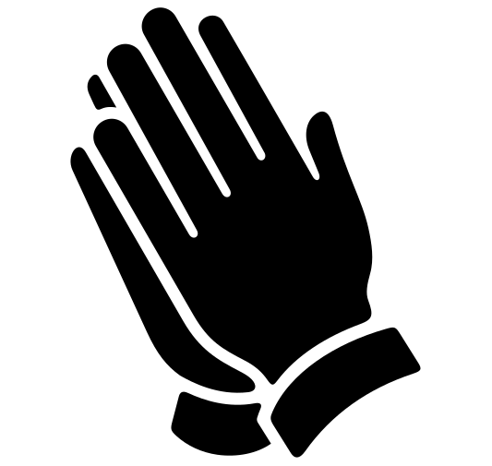Activation Station
Items needed:
- Activation Station sheet
- Crayons or colored pencils
Preparations:
- Print activation worksheet
Instructions:
- Read the top of the worksheet out loud, and invite the Holy Spirit. Have children draw or write what they are seeing from the Lord.
- Take turns sharing what the Holy Spirit showed them.

 Activity: Listening Game
Say: “When Jesus was left behind, they found him in the temple, listening to the teachers and asking questions. We are going to play a listening game.”
Items needed:
- Paper plates
- Pencil
- Scene list
Preparations:
- Print scene list
Instructions:
- Break into teams of two and have each pair sit across from each other.
- Pick one partner to be the reader and one to be the drawer. The reader is given a copy of the scene list, and the drawer is given a paper plate and a pencil.
- The reader will read one scene, while the drawer places the paper plate on top of their head and draws the scene being described. The drawer may not take the plate off their head until all the scene steps have been completed.
- The drawers remove the plates from their heads and reveal their picture.
- The volunteer will decide which team wins.
- Switch to give each person a turn to be drawer and reader.

Craft: Bible Bookmark
Items needed:
- Bookmark template
- Cardstock
- Scissors
- Crayons
- Hole punch (optional)
- Ribbon (optional)
Preparations:
- Print on cardstock
Instructions:
- Have children cut out, decorate and color.
- Hole punch and tie a ribbon through the end (optional).

