Lesson 4 - Jesus in His Father’s House II
Toddler (2 years - 4 years)

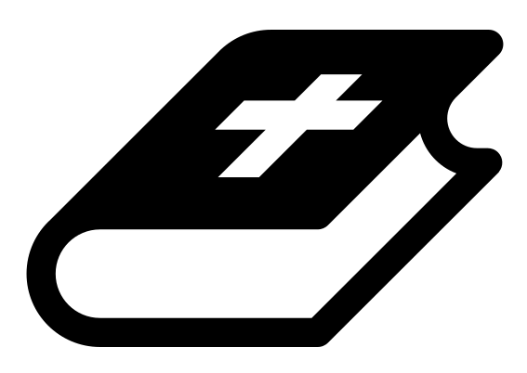 Month 2 - Bible Verse
“The angel of the Lord encamps around those who fear him, and delivers them.” Psalm 34:7

 Lesson Outline
- Arrival
- Intro
- Snack
- Bible Verse
- Lesson Video
- Lesson Questions
- Centers
- Outro
- Pick up

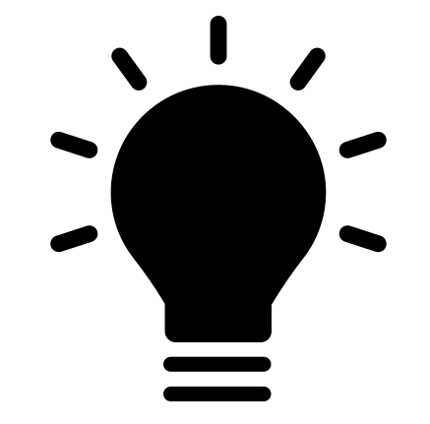 Helpful Tips
While reading the lesson or watching the video, we recommend giving the children snacks, playdough, air-dry clay, etc. This can help keep the children grounded and focused on the lesson.

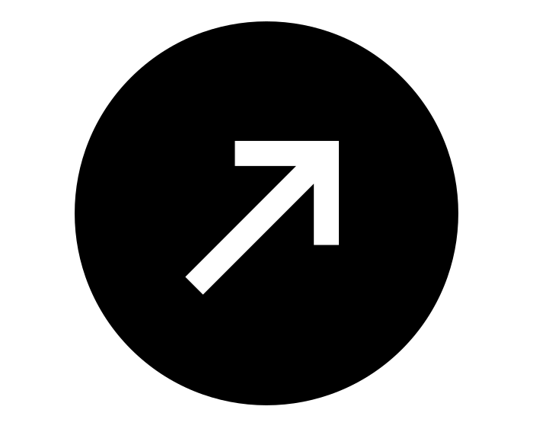Intro & Outro
Here are a few options for the beginning and end of your lesson times. Below are some suggested options:

- Worship: You can have a volunteer lead a worship song with an instrument. Worship flags and toy instruments help keep kids engaged. If you don't have a musician, a worship song or video can work.
- Brain Break: A brain break can be inserted at any point in the lesson to give everyone’s brain a break. This helps children get their wiggles out to help them focus on the lesson. You can use one of the video clips associated with this curriculum. If you don’t have video capabilities play a general game like Simon Says or Freeze Dance, etc.
- Freeplay: Divide the room into a few different stations with board games, blocks, activities, etc.

Bible Verse
Recite the monthly Bible verse (repetition is key). You can help the children make up hand motions that accompany the verse.

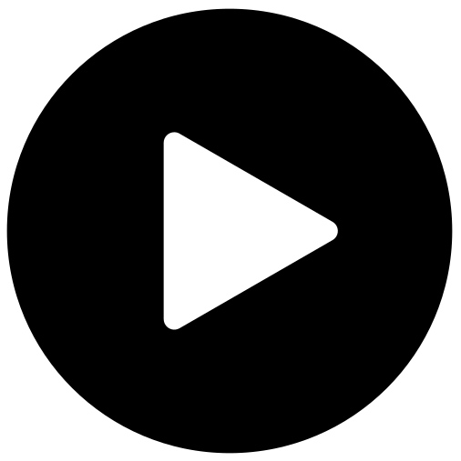 Lesson Video
Video 4- Jesus in His Father’s House (rewatch)

 Discussion Questions (answers)
- Where did they find Jesus? (in his Father’s house)
- What is “Fathers’s house” referring to? (the temple)
- What was Jesus doing? (listening to the teachers)

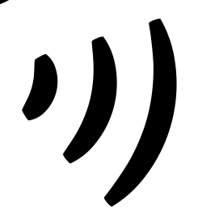 Declarations
Say this together:
I am a child of God
I am fearfully and wonderfully made
Jesus’ blood paid for EVERYTHING
Nothing can separate me from His love
With God ALL THINGS are possible
His presence is transforming my life!

 Centers
Centers are multiple activities laid out in a single classroom. After the lesson, divide the room into even groups, with one group doing the craft and the other doing the lesson activity.

 Activity: Dot to Dot
Say: “We need obedience to follow directions and complete the dot to dot.”
Items needed:
- Dot to dot (toddler version)
- Markers
Preparations:
- Print
Instructions:
- Help children use the dot markers to place dots in each circle.

Craft: My Father’s House Door Hanger
Items needed:
- Door hanger template
- Crayons
Preparations:
- Print and cut out
Instructions:
- Allow children to color.
- Take home, and hang on your door.

