Lesson 4 - Jesus in His Father’s House II
Pre K - Kinder (Preschool - Kindergarten)

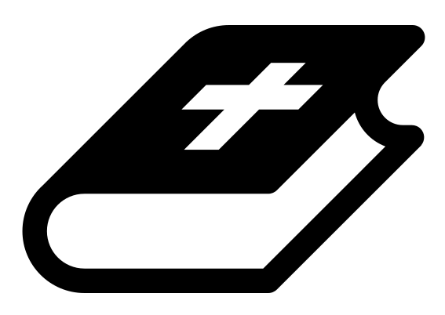 Month 2 - Bible Verse
“The angel of the Lord encamps around those who fear him, and delivers them.” Psalm 34:7

 Lesson Outline
- Arrival
- Intro
- Snack
- Bible Verse & Teaching
- Lesson Video
- Lesson Questions
- Declarations
- Centers
- Outro
- Pick up

Intro & Outro
Here are a few options for the beginning and end of your lesson times. Below are some suggested options:

- Worship: You can have a volunteer lead a worship song with an instrument. Worship flags and toy instruments help keep kids engaged. If you don't have a musician, a worship song or video can work.
- Brain Break: A brain break can be inserted at any point in the lesson to give everyone’s brain a break. This helps children get their wiggles out to help them focus on the lesson. You can use one of the video clips associated with this curriculum. If you don’t have video capabilities play a general game like Simon Says or Freeze Dance, etc.
- Freeplay: Divide the room into a few different stations with board games, blocks, activities, etc.

Bible Verse and Teaching
Recite the monthly Bible verse (repetition is key). You can help the children make up hand motions that go with the verse.

Then say: “Last week we talked about a story when Jesus was a young boy. Does anyone remember what happened? (Let children answer) Yes, Jesus and his family were on their way back from Jerusalem, and Jesus was left behind! Can you imagine? Who knows where Jesus was found? (Let children answer) Yes, He was in the temple, listening to the teachers of Israel.

“So after this, the Bible doesn’t say much more about Jesus’s childhood. But in Luke it says that Jesus continued to be obedient toward his parents, and he grew ‘in wisdom and stature and in favor with God and all people.’

“Let’s watch our video!”

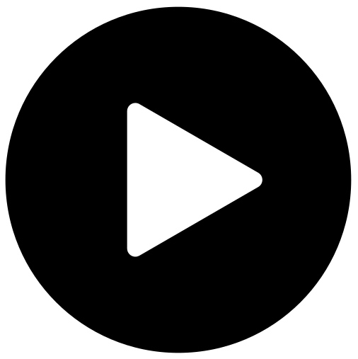 Lesson Video
Video 4- Jesus in His Father’s House (rewatch)

 Discussion Questions
- What does Luke say Jesus continued to do as he grew up? (obey; grow in stature, wisdom and favor)
- How does Jesus as a young child set an example for us? (in the way he obeys his parents)

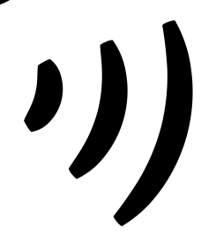 Declarations
Say this together:
I am a child of God
I am fearfully and wonderfully made
Jesus’ blood paid for EVERYTHING
Nothing can separate me from His love
With God ALL THINGS are possible
His presence is transforming my life!

 Centers
Centers are multiple activities laid out in a single classroom. After the lesson, divide the room into even groups, with one group doing the craft and the other doing the lesson activity.

 Activity: Dot to Dot
Say: “We need obedience to follow directions and complete the dot to dot.”
Items needed:
- Dot to dot
- pencil
Preparations:
- Print

Craft: My Father’s House Door Hanger
Items needed:
- Door hanger template
- Crayons
Preparations:
- Print and cut out
Instructions:
- Allow children to color.
- Take home, and hang on your door.

