Lesson 4 - Jesus in His Father’s House II
Elementary (4th grade - 6th grade)

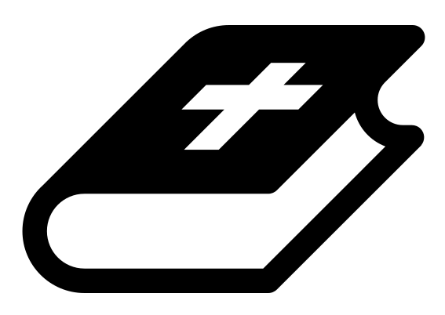 Month 2 - Bible Verse
“The angel of the Lord encamps around those who fear him, and delivers them.” Psalm 34:7

 Lesson Outline
- Arrival
- Intro
- Snack
- Memory Verse
- Bible Reading & Discussion
- Lesson Video
- Declarations
- Activation Station
- Craft/Activity
- Outro
- Pick up

Intro & Outro
Here are a few options for the beginning and end of your lesson times. Below are some suggested options:

- Worship: You can have a volunteer lead a worship song with an instrument. Worship flags and toy instruments help keep kids engaged. If you don't have a musician, a worship song or video can work.
- Centers: Divide the room into a few different stations, for example, one with card games, another with free drawing/coloring, etc.

Bible Verse and Teaching
Recite the monthly Bible verse (repetition is key). You can help the children make up hand motions that go with the verse.

Then say: “Last week we talked about a story when Jesus was a young boy. Does anyone remember what happened? (Let children answer) Yes, Jesus and his family were on their way back from Jerusalem, and Jesus was left behind! Can you imagine? Who knows where Jesus was found? (Let children answer) Yes, He was in the temple, listening to the teachers of Israel.

“So after this, the Bible doesn’t say much more about Jesus’s childhood. But in Luke it says that Jesus continued to be obedient toward his parents, and he grew ‘in wisdom and stature and in favor with God and all people.’

“Let’s watch our video!”

 Lesson Video
Video 4- Jesus in His Father’s House (rewatch)

 Discussion Questions
- What does Luke say Jesus continued to do as he grew up? (obey; grow in stature, wisdom and favor)
- How does Jesus as a young child set an example for us? (in the way he obeys his parents)

Bible Reading & Discussion
Allow around 15-20 min for this section. Give each student a Bible. Break students into groups and assign them a scripture to read together. After they have some time to discuss, have them nominate a group member to read the scripture and share what they think it means.

Verses & Questions
- Luke 2:41-52
  - In the last two verses what does Jesus do? (He is obedient to his parents.)
  - What happens to Jesus because he obeys his parents? (He grows and gets smarter and gains wisdom; he gets physically stronger and can take on more responsibility; he is thought well of by people around him and by God.)

 Declarations
Say this together:
I am a child of God
I am fearfully and wonderfully made
Jesus’ blood paid for EVERYTHING
Nothing can separate me from His love
With God ALL THINGS are possible
His presence is transforming my life!

Activation Station
Items needed:
- Activation Station sheet
- Crayons or colored pencils
Preparations:
- Print activation worksheet
Instructions:
- Read the top of the worksheet out loud, and invite the Holy Spirit. Have children draw or write what they are seeing from the Lord.
- Take turns sharing what the Holy Spirit showed them.

 Activity: Dot to Dot
Say: “We need obedience to follow directions and complete the dot to dot.”
Items needed:
- Dot to dot
- pencil
Preparations:
- Print

Craft: My Father’s House Door Hanger
Items needed:
- Door hanger template
- Crayons
Preparations:
- Print and cut out
Instructions:
- Allow children to color.
- Take home, and hang on your door.

