Lesson 1 - The Birth of Jesus
Toddler (2 years - 4 years)

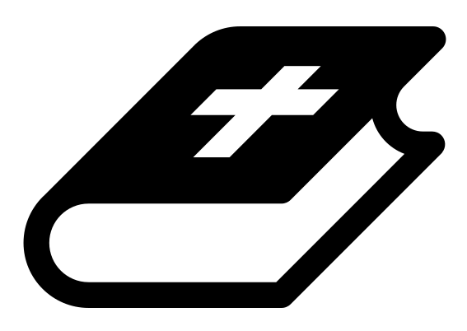 Month 2 - Bible Verse
“The angel of the Lord encamps around those who fear him, and delivers them.” Psalm 34:7

 Lesson Outline
- Arrival
- Intro
- Snack
- Bible Verse
- Lesson Video
- Lesson Questions
- Centers
- Outro
- Pick up

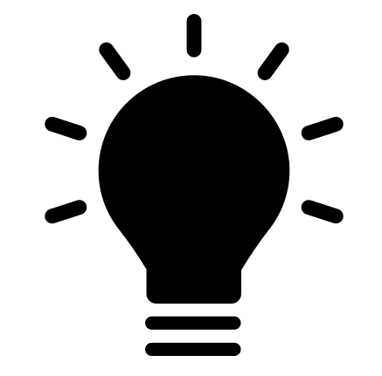 Helpful Tips
While reading the lesson or watching the video, we recommend giving the children snacks, playdough, air-dry clay, etc. This can help keep the children grounded and focused on the lesson.

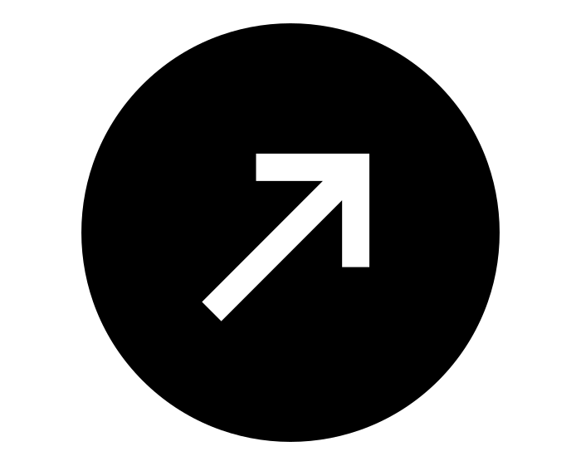Intro & Outro
Here are a few options for the beginning and end of your lesson times. Below are some suggested options:

- Worship: You can have a volunteer lead a worship song with an instrument. Worship flags and toy instruments help keep kids engaged. If you don't have a musician, a worship song or video can work.
- Brain Break: A brain break can be inserted at any point in the lesson to give everyone’s brain a break. This helps children get their wiggles out to help them focus on the lesson. You can use one of the video clips associated with this curriculum. If you don’t have video capabilities play a general game like Simon Says or Freeze Dance, etc.
- Freeplay: Divide the room into a few different stations with board games, blocks, activities, etc.

Bible Verse
Recite the monthly Bible verse (repetition is key). You can help the children make up hand motions that accompany the verse.

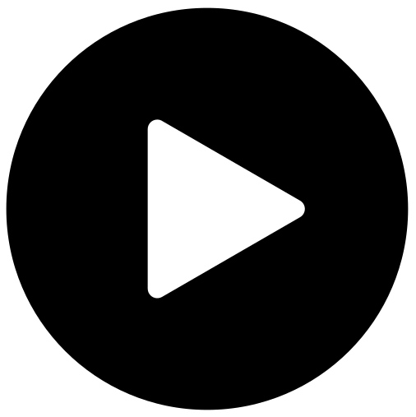 Lesson Video
Video 3- The Birth of Jesus

 Discussion Questions
- What was the king's name who wanted to kill Jesus? (King Herod)
- Why did he want to kill Jesus? (He thought Jesus would take his throne.)
- How were the wise men warned? (a dream from God)

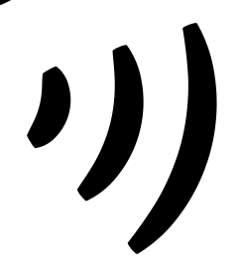 Declarations
Say this together:
I am a child of God
I am fearfully and wonderfully made
Jesus’ blood paid for EVERYTHING
Nothing can separate me from His love
With God ALL THINGS are possible
His presence is transforming my life!

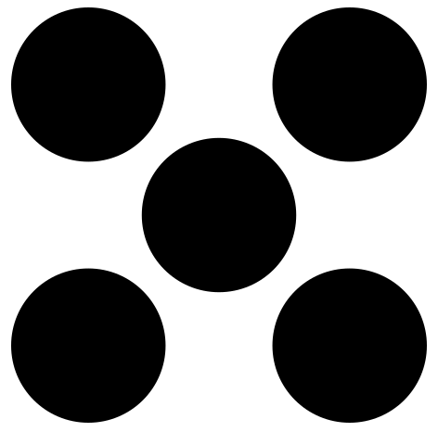 Centers
Centers are multiple activities laid out in a single classroom. After the lesson, divide the room into even groups, with one group doing the craft and the other doing the lesson activity.

 Activity: Dreaming Magi
Instructions:
- Have children walk about the room randomly.
- When a volunteer says, “Magi, go to sleep,” the children must quickly lay on the floor and pretend to sleep.
- While they lay on the ground, a volunteer says, “God says you're dreaming about…” and the volunteer will call out an action (examples: swimming, skipping, dancing).
- The children must jump up and do that action until the volunteer says, “Magi, go to sleep.”
- However, students must listen carefully, because if a volunteer says an action without first saying “God says,” then the children must stay asleep. Anyone who makes a mistake is out! This is a play on Simon Says.

Craft: Maji Coloring Sheet
Items needed:
- Maji coloring sheet
Preparations:
- Print
Instructions:
- Allow children to color.

