Lesson 2 - The Birth of Jesus II
Nursery (6 mo - 2 years)

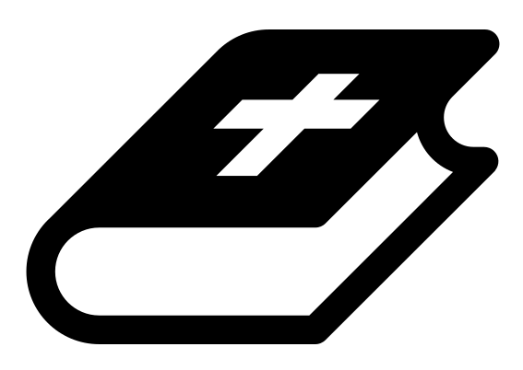 Month 2 - Bible Verse
“The angel of the Lord encamps around those who fear him, and delivers them.” Psalm 34:7

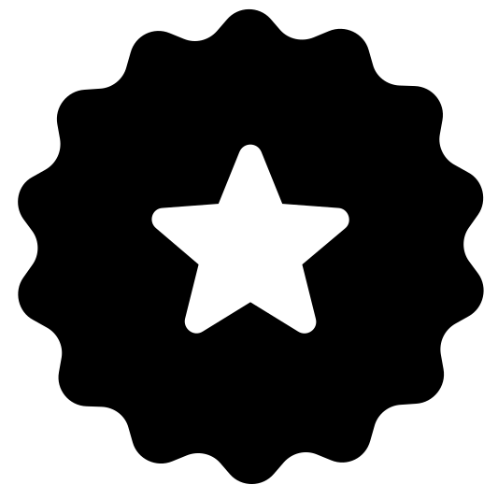 Main Goals
Create a safe environment. Impart God’s love and blessing through your words, body language, and attitude in your interactions with the children.

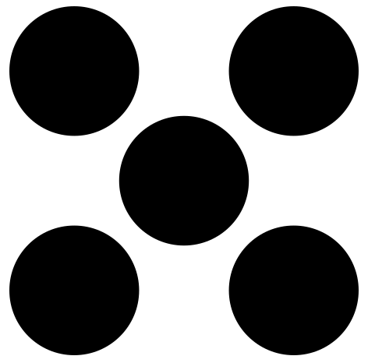 Centers
Centers are multiple activities laid out in a single classroom. For example, lay out the room with three different play activities before children enter. Allow the children to choose which one they would like to engage with.
- Freeplay (i.e. playdough, blocks, toys)
- Activity (i.e. a lesson-based activity or craft)

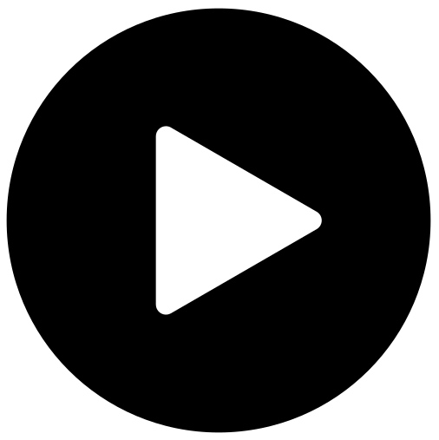 Lesson Video
Video 3- The Birth of Jesus (rewatch)

 Craft: Psalm 34:7 Coloring Sheet
Items needed:
- Psalm 34:7 coloring sheet
- Crayons
Preparations:
- Print
Instructions:
- Allow children to color.

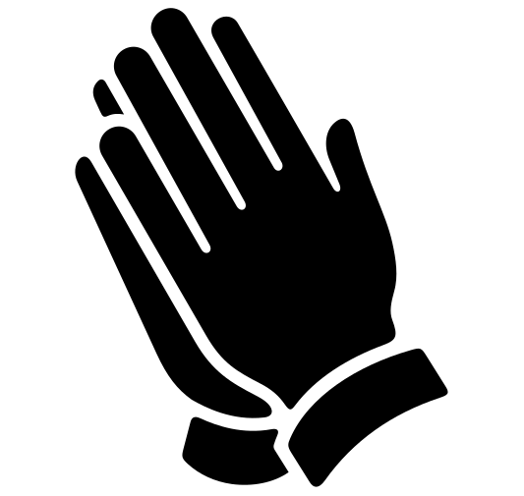Prayer Tips
Start with Thanksgiving:
“Thank you God for your protection over our lives.”
“Thank you God that you provide for our every need.”

Worship God (turn your heart towards the Lord):
Worship while holding or sitting with babies, telling God who He is.
Tell God:
- “God, you are our caring Father.”
- “God, you sustain us.”

Intercede for the children:
Pray for each baby and for their families.

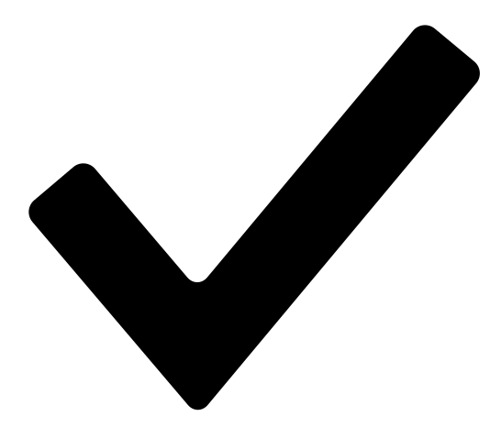 Prayer Points
- Pray that these children would have dreams from heaven.
- Pray that God’s goodness and mercy would follow them.
- Pray protection over them and that they would fear the Lord.

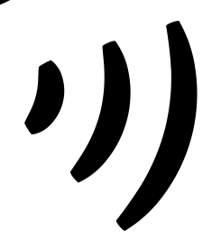 Declarations
Say this together:
I am a child of God
I am fearfully and wonderfully made
Jesus’ blood paid for EVERYTHING
Nothing can separate me from His love
With God ALL THINGS are possible
His presence is transforming my life!

