Lesson 2 - The Birth of Jesus II
Pre K - Kinder (Preschool - Kindergarten)

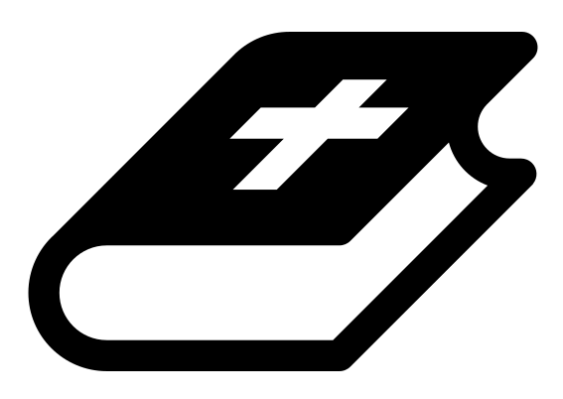 Month 2 - Bible Verse
“The angel of the Lord encamps around those who fear him, and delivers them.” Psalm 34:7

 Lesson Outline
- Arrival
- Intro
- Snack
- Bible Verse & Teaching
- Lesson Video
- Lesson Questions
- Declarations
- Centers
- Outro
- Pick up

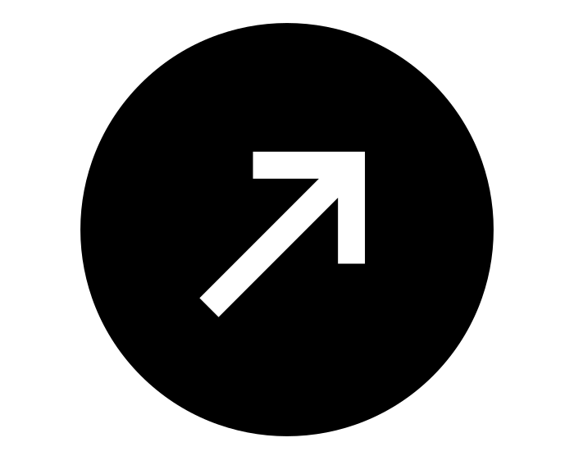Intro & Outro
Here are a few options for the beginning and end of your lesson times. Below are some suggested options:

- Worship: You can have a volunteer lead a worship song with an instrument. Worship flags and toy instruments help keep kids engaged. If you don't have a musician, a worship song or video can work.
- Brain Break: A brain break can be inserted at any point in the lesson to give everyone’s brain a break. This helps children get their wiggles out to help them focus on the lesson. You can use one of the video clips associated with this curriculum. If you don’t have video capabilities play a general game like Simon Says or Freeze Dance, etc.
- Freeplay: Divide the room into a few different stations with board games, blocks, activities, etc.

Bible Verse and Teaching
Recite the monthly Bible verse (repetition is key). You can help the children make up hand motions that go with the verse.

Then say: “Last week we talked about the birth of Jesus. King Herod wanted to kill Jesus, but God warned the wise men in a dream.

“God also gave Joseph (Jesus’ dad) a dream, telling him to leave Bethlehem and go to Egypt. Why did God have them leave Bethlehem? (Let children answer) They left because King Herod was about to do a very evil thing. He commanded all the baby boys in Bethlehem to be killed.

“When looking at Jesus' birth, can you see how God protected him? (Let children answer) This is the same for our lives: even though we live in a fallen world, and evil things still happen, God’s protection covers us.”

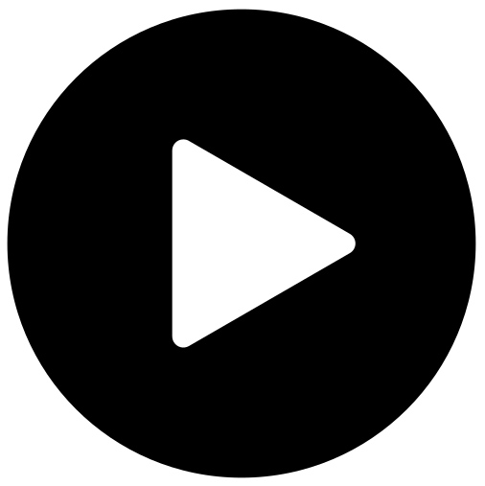 Lesson Video
Video 3- The Birth of Jesus (rewatch)

 Discussion Questions (answers)
- How did God warn Joseph? (in a dream)
- Where did God tell Joseph to go? (to Egypt)
- Tell me about a time God protected you.

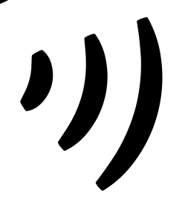 Declarations
Say this together:
I am a child of God
I am fearfully and wonderfully made
Jesus’ blood paid for EVERYTHING
Nothing can separate me from His love
With God ALL THINGS are possible
His presence is transforming my life!

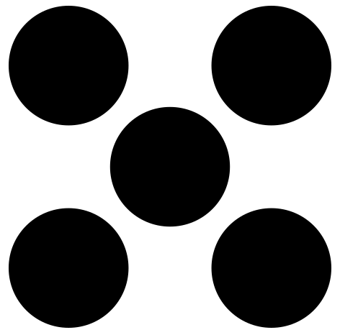 Centers
Centers are multiple activities laid out in a single classroom. After the lesson, divide the room into even groups, with one group doing the craft and the other doing the lesson activity.

 Activity: God Says (Simon Says)
Say: “God gave Joseph and the magi dreams to warn them and protect them. They had to listen carefully and obey God. Let’s play a game to see how well you listen and obey.”
Instructions:
- Play Simon Says, but instead of saying “Simon,” say “God says.”
- The last person standing wins.

Craft: Psalm 34:7 Craft
Items needed:
- Psalm 34:7 craft
- Cardstock
- Scissors
- Glue
Preparations:
- Print on cardstock
Instructions:
- Follow directions on the craft sheet. (Note: The toilet paper roll is optional; you can simply roll and glue the cardstock.)

