Lesson 2 -Victory Over Temptation
Nursery (6 mo - 2 years)

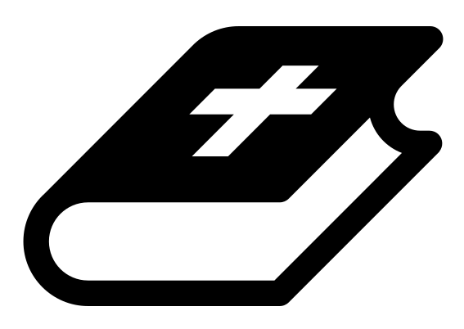 Month 3 - Bible Verse
“For we do not have a high priest who is unable to empathize with our weaknesses, but we have one who has been tempted in every way, just as we are—yet he did not sin.” Hebrews 4:15

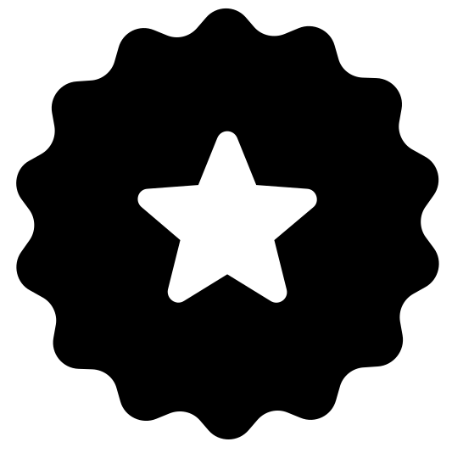 Main Goals
Create a safe environment. Impart God’s love and blessing through your words, body language, and attitude in your interactions with the children.

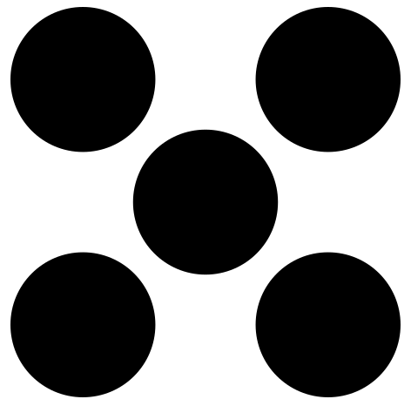 Centers
Centers are multiple activities laid out in a single classroom. For example, lay out the room with three different play activities before children enter. Allow the children to choose which one they would like to engage with.
- Freeplay (i.e. playdough, blocks, toys)
- Activity (i.e. a lesson-based activity or craft)

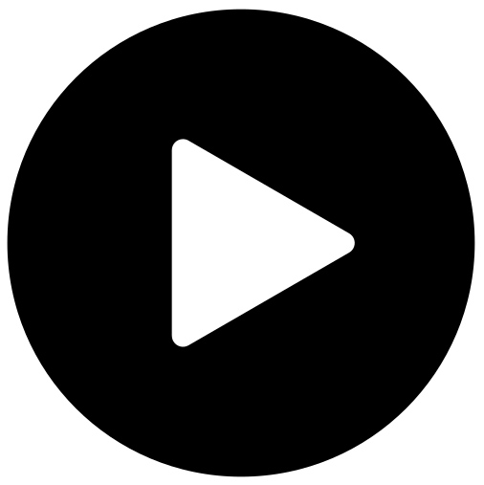 Lesson Video
Video 5- The Temptation of Jesus (rewatch)

 Craft: Sword Coloring Sheet
Items needed:
- Sword coloring sheet
- Crayons
Preparations:
- Print
Instructions:
- Allow children to color.

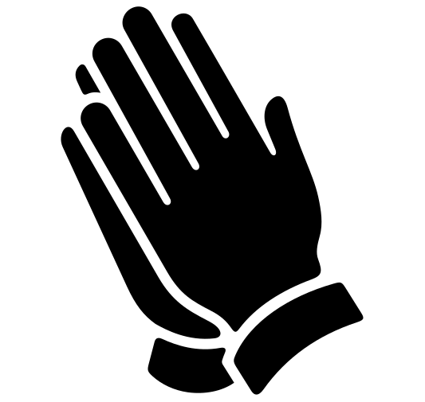Prayer Tips
Start with Thanksgiving:
“Thank you God that you reign over our enemy.”
“Thank you God for your protection from the schemes of Satan.”

Worship God (turn your heart towards the Lord):
Worship while holding or sitting with babies, telling God who He is.
Tell God:
- “God, you are our protector.”
- “God, you are our High King.”

Intercede for the children:
Pray for each baby and for their families.

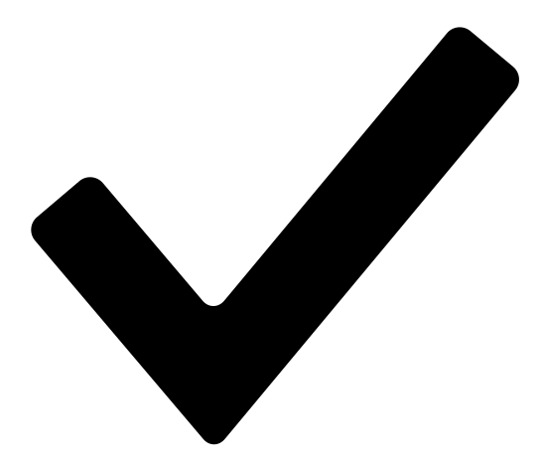 Prayer Points
- Pray that these children and their families would be hidden from the evil one.
- Read Psalm 91 over them.
- Pray that they would have victory over temptation.

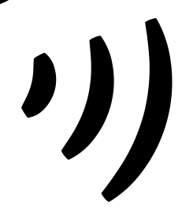 Declarations
Say this together:
I am a child of God
I am fearfully and wonderfully made
Jesus’ blood paid for EVERYTHING
Nothing can separate me from His love
With God ALL THINGS are possible
His presence is transforming my life!

