Lesson 2 - Victory Over Temptation
Elementary (1st grade - 3rd grade)

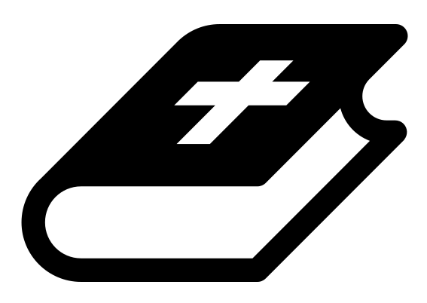 Month 3 - Bible Verse
“For we do not have a high priest who is unable to empathize with our weaknesses, but we have one who has been tempted in every way, just as we are—yet he did not sin.” Hebrews 4:15
 Lesson Outline
- Arrival
- Intro
- Snack
- Bible Verse & Teaching
- Lesson Video
- Discussion Questions
- Declarations
- Activation Station
- Centers
- Outro
- Pick up

Intro & Outro
Here are a few options for the beginning and end of your lesson times. Below are some suggested options:

- Worship: You can have a volunteer lead a worship song with an instrument. Worship flags and toy instruments help keep kids engaged. If you don't have a musician, a worship song or video can work.
- Brain Break: A brain break can be inserted at any point in the lesson to give everyone’s brain a break. This helps children get their wiggles out to help them focus on the lesson. You can use one of the video clips associated with this curriculum. If you don’t have video capabilities play a general game like Simon Says or Freeze Dance, etc.
- Freeplay: Divide the room into a few different stations with board games, blocks, activities, etc.

Bible Verse and Teaching
Recite the monthly Bible verse (repetition is key). You can help the children make up hand motions that go with the verse.

Then say: “Last week we talked about the story of when Satan tempted Jesus in the wilderness. Does anyone remember what happened? (Let children answer) So God led Jesus into the wilderness, and Satan came and tried to trick him. Do you know many times? (Let children answer) Yes, three times. Do you remember how Jesus responded to Satan? (Let children answer) Yes! With the Word of God! When Jesus would respond to Satan, he would quote scripture.

“Hebrews says that the word of God is sharper than a two-edged sword, meaning you and I can fight our battles with it! That is also why the sword (the Bible) is part of the armor of God that we are supposed to put on daily! Our sword will pierce through the lies of the evil one and help protect our hearts from temptation.

“Who’s ready to pick up their sword?”

 Lesson Video
Video 5- The Temptation of Jesus (rewatch)

 Discussion Questions (answers)
- What can we use to fight Satan? (the word of God)
- What does Hebrews say the word is like? (sharper than a two-edged sword)
- How can you pick up your sword daily? (let children answer)

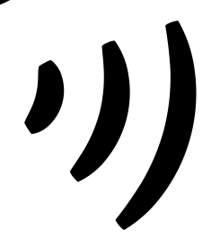 Declarations
Say this together:
I am a child of God
I am fearfully and wonderfully made
Jesus’ blood paid for EVERYTHING
Nothing can separate me from His love
With God ALL THINGS are possible
His presence is transforming my life

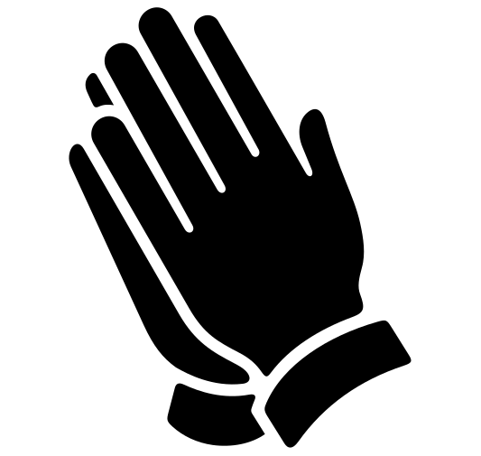Activation Station
Items needed:
- Activation Station sheet
- Crayons or colored pencils
Preparations:
- Print activation worksheet
Instructions:
- Read the top of the worksheet out loud, and invite the Holy Spirit. Have children draw or write what they are seeing from the Lord.
- Take turns sharing what the Holy Spirit showed them.

 Centers
Centers are multiple activities laid out in a single classroom. After the lesson, divide the room into even groups with one group doing the craft and one group doing the lesson activity.

 Activity: Sword Drill
Say: “The Bible is sharper than a two-edged sword, so we need to know it well and be ready at all times to use it to fight the schemes of the enemy.”

Items needed:
- 7 plastic knives
- Permanent marker
- Bibles (one per group)
Preparations:
- With permanent marker, write the verses on plastic knives (listed below)
- Place all knives in a cup, sharp side down
Verses:
- James 4:7
- Psalm 23:4
- 1 Peter 5:8
- Ephesians 6:17
- 2 Thessalonians 3:3
- Romans 8:37-39
- 1 Corinthians 10:13

Instructions:
- Split the room into groups and give each group a Bible.
- At random, select a knife out of the cup.
- At your signal, each group races to find that verse in their Bible. The first team to find the verse gets to keep that knife.
- Read the verse out loud (volunteers help with this).
- Repeat with the remaining knives.
- The team with the most knives at the end wins!

Craft: Sword Cards
Say: “Take these cards home, and let them be a reminder of the power you have through the word of God!”

Items needed:
- Sword cards
- Scissors
- Hole punch
- Yarn
- Crayons
Preparations:
- Print
- Cut out
Instructions:
- Have children decorate their cards.
- Hole punch the cards and attach with a piece of yarn.

