Lesson 2 - Victory Over Temptation
Elementary (4th grade - 6th grade)

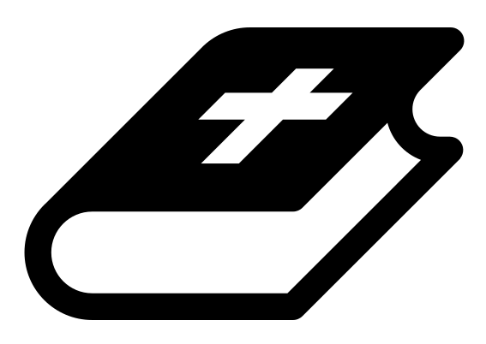 Month 3 - Bible Verse
“For we do not have a high priest who is unable to empathize with our weaknesses, but we have one who has been tempted in every way, just as we are—yet he did not sin.” Hebrews 4:15

 Lesson Outline
- Arrival
- Intro
- Snack
- Memory Verse
- Bible Reading & Discussion
- Lesson Video
- Declarations
- Activation Station
- Craft/Activity
- Outro
- Pick up

Intro & Outro
Here are a few options for the beginning and end of your lesson times. Below are some suggested options:

- Worship: You can have a volunteer lead a worship song with an instrument. Worship flags and toy instruments help keep kids engaged. If you don't have a musician, a worship song or video can work.
- Centers: Divide the room into a few different stations, for example, one with card games, another with free drawing/coloring, etc.

Bible Verse and Teaching
Recite the monthly Bible verse (repetition is key). You can help the children make up hand motions that go with the verse.

Then say: “Last week we talked about the story of when Satan tempted Jesus in the wilderness. Does anyone remember what happened? (Let children answer) So God led Jesus into the wilderness, and Satan came and tried to trick him. Do you know many times? (Let children answer) Yes, three times. Do you remember how Jesus responded to Satan? (Let children answer) Yes! With the Word of God! When Jesus would respond to Satan, he would quote scripture.

“Hebrews says that the word of God is sharper than a two-edged sword, meaning you and I can fight our battles with it! That is also why the sword (the Bible) is part of the armor of God that we are supposed to put on daily! Our sword will pierce through the lies of the evil one and help protect our hearts from temptation.

“Who’s ready to pick up their sword?”

 Lesson Video
Video 5- The Temptation of Jesus (rewatch)

 Discussion Questions (answers)
- What can we use to fight Satan? (the word of God)
- What does Hebrews say the word is like? (sharper than a two-edged sword)
- How can you pick up your sword daily? (let children answer)

Bible Reading & Discussion
Allow around 15-20 min for this section. Give each student a Bible. Break students into groups and assign them a scripture to read together. After they have some time to discuss, have them nominate a group member to read the scripture and share what they think it means.

Verses & Questions
- Luke 4:1-13
  - How many times is Jesus tempted, and with what? (3 times: 1. Turning stones to bread, 2. Bowing down to Satan in exchange for wealth and kingdoms, 3. Showing everyone he’s the Son of God by forcing God to deliver him. Each time, Satan is trying to attack Jesus’ identity and future destiny in exchange for meeting his immediate needs.)
  - What does Jesus say when he’s tempted? (“It is written…” he quotes scripture from Deuteronomy (Deut. 8:3))
  - What should we do when we are tempted? (We should know scripture in our hearts and say it in moments of temptation just like Jesus.)
- Hebrews 2:17-18
  - Jesus is able to help us when we are tempted because he knows what it’s like to be tempted.

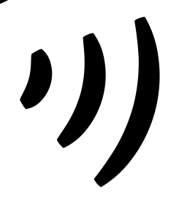 Declarations
Say this together:
I am a child of God
I am fearfully and wonderfully made
Jesus’ blood paid for EVERYTHING
Nothing can separate me from His love
With God ALL THINGS are possible
His presence is transforming my life!

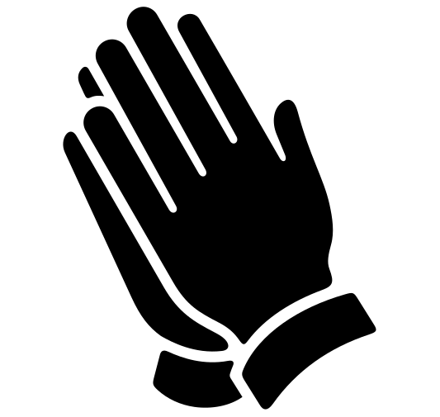Activation Station
Items needed:
- Activation Station sheet
- Crayons or colored pencils
Preparations:
- Print activation worksheet
Instructions:
- Read the top of the worksheet out loud, and invite the Holy Spirit. Have children draw or write what they are seeing from the Lord.
- Take turns sharing what the Holy Spirit showed them.

 Activity: Sword Drill
Say: “The Bible is sharper than a two-edged sword, so we need to know it well and be ready at all times to use it to fight the schemes of the enemy.”
Items needed:
- 7 plastic knives
- Permanent marker
- Bibles (one per group)
Preparations:
- With permanent marker, write the verses on plastic knives (listed below)
- Place all knives in a cup, sharp side down
Verses:
- James 4:7
- Psalm 23:4
- 1 Peter 5:8
- Ephesians 6:17
- 2 Thessalonians 3:3
- Romans 8:37-39
- 1 Corinthians 10:13
Instructions:
- Split the room into groups and give each group a Bible.
- At random, select a knife out of the cup.
- At your signal, each group races to find that verse in their Bible. The first team to find the verse gets to keep that knife.
- Read the verse out loud (volunteers help with this).
- Repeat with the remaining knives.
- The team with the most knives at the end wins!

Craft: Sword Cards
Say: “Take these cards home, and let them be a reminder of the power you have through the word of God!”
Items needed:
- Sword cards
- Scissors
- Hole punch
- Yarn
- Crayons
Preparations:
- Print
- Cut out
Instructions:
- Have children decorate their cards.
- Hole punch the cards and attach with a piece of yarn.

